

**目　　次**

1. **平成28年度盲ろう者国際協力推進事業海外調査要領** 1
2. **海外調査日程および調査期間等**　 2
3. **調査報告** 4

**１．シンガポール盲ろう者支援プロジェクト** 4

1.1　盲ろう啓発トーク「盲ろう者とはなにか。

日本とシンガポールの盲ろう者事情」 4

1.2　シンガポールろう者協会訪問 7

1.3　通訳・介助員養成講座（導入） 7

1.4　Disabled Peoples’ Association 訪問 10

1.5 VWO及び政府機関との盲ろう者支援体制作りのための

ネットワーク形成に向けて　―ステークホルダー

ミーティング― 11

1.6 福祉機器の視察及び意見交換 12

1.7 シンガポール視覚障害者協会訪問 13

1.8 盲ろう児宅訪問 14

**２.　タイ　「アジア太平洋障害者の十年（2013-2022）」**

**ワーキンググループ第４セッション　出席** 15

2.1　概要 15

2.2　背景 15

2.3　プログラム 16

**３.　マレーシア盲ろう者支援プロジェクトフォローアップ** 16

3.1　概要・背景 16

3.2　主な活動報告 16

**４.　レソト盲ろう者支援プロジェクト事前調査** 17

4.1　概要・背景 17

4.2　プログラム 17

4.3　報告 18

**５.　ウズベキスタン指点字講習会** 18

5.1　概要・背景 18

**６.　その他会議等** 20

**参考資料** 21

　①　ESCAP Report on the Fourth Session of

the Working Group on the Asian and Pacific Decade of

Persons with Disabilities, 2013-2022 21

　　　　②　Draft Midpoint Evaluation on the Effectiveness of

the Working Group on the Asian and Pacific Decade of

Persons with Disabilities, 2013-2022 (Revised) 40

③　ウズベキスタン指点字講習会プロポーザル 64

**Ⅰ　平成28年度盲ろう者国際協力推進事業海外調査要領**

**１　目的**

本調査は、調査員を世界盲ろう者連盟加盟国等へ派遣し、それらの国における盲ろう者福祉に関する施策の実施状況等について実地に調査し、世界各国の盲ろう者および盲ろう者関係団体等に必要な情報を提供することにより、盲ろう者をはじめ盲ろう者関係団体等の協力関係の構築および活動の強化を図ることを目的とする。

**２　主催**

社会福祉法人　全国盲ろう者協会

**３　調査実施国**

シンガポール、タイ、マレーシア、レソト、ウズベキスタン

**４　調査項目**

・盲ろう者のおかれている現状

・盲ろう者支援システムの現状

・盲ろう者支援システム構築のための関係団体の有無と現状

・盲ろう者組織ならびにネットワークの現状

・盲ろう者の就労・職業訓練等の現状

・その他

**５　調査実施期間**

シンガポール　　　平成29（2017）年3月4日～3月7日

タイ　　　　　　　平成29（2017）年3月1日～3月2日

マレーシア　　　　平成28（2016）年9月15日～10月14日

レソト　　　　　　平成28（2016）年12月19日～12月21日

ウズベキスタン　　平成29（2017）年3月12日

**６　調査の実施方法**

実地調査は、調査機関および会議等を訪問し、情報収集を行い、また、盲ろう当事者・サービス提供者・支援者等から聞き取り調査を行う。

**Ⅱ　海外調査日程および調査期間等**

**シンガポール**

日　　程：平成29（2017）年3月4日

調査内容：盲ろう啓発トーク

「盲ろうとはなにか。日本とシンガポールの盲ろう者事情」

日　　程：平成29（2017）年3月5日

調査内容：シンガポールろう協会訪問（Singapore Deaf Association）

日　　程：平成29（2017）年3月5日

調査内容：通訳・介助員養成講座（導入）

日　　程：平成29（2017）年3月6日

調査内容：Disabled Peoples’Association 訪問

日　　程：平成29（2017）年3月6日

調査内容：VWO及び政府機関との盲ろう者支援体制作りのためのネットワーク形成に向けて　―ステークホルダーミーティング―

日　　程：平成29（2017）年3月6日

調査内容：福祉機器の視察及び意見交換

日　　程：平成29（2017）年3月7日

調査内容：シンガポール視覚障害者協会（Singapore Association of the Visually Handicapped）訪問

日　　程：平成29（2017）年3月7日

調査内容：盲ろう児宅訪問

**タイ**

日　　程：平成29（2017）年3月1日～2日

調査内容：「アジア太平洋障害者の十年（2013-2022）」

ワーキンググループ第４セッション　出席

**マレーシア**

日　　程：平成28（2016）年9月15日～10月14日

調査内容：マレーシアろう協会・マレーシア視覚障害者協議会へ

盲ろう当事者インターン派遣の補助

**レソト**

日　　程：平成28（2016）年12月19日～12月21日

調査内容：レソト王国での、盲ろう者の状況調査

盲ろう者支援プロジェクトの事前調査

**ウズベキスタン**

日　　程：平成29（2017）年3月12日

調査内容：指点字講習会のサポート（講師向け研修等）

**Ⅲ　調査報告**

**１．シンガポール盲ろう者支援プロジェクト**

目的

本調査の目的は、シンガポールにおける盲ろう者の現状とニーズの調査、支援リソースの有無、関係団体訪問及び情報共有、関連する政府担当者と支援団体代表者との支援組織構築へ向けての協議を行うことである。同時に、ASEAN障害フォーラムのフォーカルポイントとも協力関係を強化し、ASEAN諸国における障害団体ネットワークに盲ろうという障害を包摂するための方向性を模索する。

調査員

福田暁子（WFDB事務局長）

通訳・介助員およびヘルパー：杉浦節子、和田みさ、木内萌乃

城田さち（日英通訳者）

滝澤亜紀（日英通訳者）

日程

平成29（2017）年3月3日～3月8日（移動日を含む）

**1.1 盲ろう啓発トーク「盲ろうとはなにか。日本とシンガポールの盲ろう者事情」**

日程：平成29（2017）年3月4日

会場：Enabling Village

住所：20 Lengkok Bahru, Singapore 159053

主催：Society for the Physically Disabled (SPD)、全国盲ろう者協会

**1.1.1 概要・背景**

シンガポールにおいて、盲ろう者の状況の把握は組織的に行われておらず、視覚と聴覚の両方に障害がある人のことを「盲ろう者」と呼ぶということも、社会的にも、福祉分野の中でもほとんど認識されていない。しかし、当然ながら、一定の割合で聴覚障害者グループ、視覚障害者グループ、または重複障害への支援グループの中には盲ろう者の存在は確認されてきた。

その中で、聴覚障害者で弱視であるイー・チャン・ロー氏（呼称はリサ）が、公益財団法人ダスキン「愛の輪運動基金」のアジア太平洋障害者リーダー育成事業の第16期生として、2015年から2016年にかけて日本で10ヶ月に渡り、盲ろう者の社会参加と支援のあり方について研修を受けた。帰国後、盲ろう者の掘り起こし、外出活動、訪問活動などを展開している。全国盲ろう者協会ではリサ氏の個人研修を一部受け入れた経緯もあり、シンガポールでさらに盲ろうについての啓発を行う目的も兼ねて、啓発トークを共催することとした。

**1.1.2 プログラム**

10：00～16：00

・「盲ろう」について（福田氏による講義）

・「盲ろう者としての私の生活」（福田氏による講演と質疑応答）

・「シンガポールの盲ろう者の現状」（イー・チャン・ロー氏による報告）

・盲ろう者にはどのような支援が必要なのか。日本の通訳・介助員派遣制度の紹介と意見交換。

**1.1.3 報告**

ろう者、肢体不自由者、精神障害者、健常者の支援者など全体で40名弱の参加があった。

3名の盲ろう者の参加もあり、昼食の休憩時間等を利用して、それぞれの盲ろう者と話をすることができた。健聴者の中には実際に盲ろう者の支援にあたっているソーシャルワーカー、盲ろう者を含む障害者の福祉機器の支援の専門員、メディア関係者などが含まれる。盲ろう者への通訳は、全体手話通訳者とは別に、ろう者によってリレー形式での通訳方法がとられた。

シンガポールの手話がASLから多くを転用したものであること、公用語に英語が使われていたので、コミュニケーションは比較的とりやすかった。盲ろう者とのコミュニケーションは通訳を介して行ったが、弱視手話でも手話の読み取りが難しくなっていると思われる男性は、「毎日行くところもやることもなく、退屈で寝てばっかりだ。仕事はしていない」と繰り返し話していた。白杖を携帯しており、家族と思われる女性が移動介助をしていた。

英語字幕をつけた盲ろう者に関するDVDを見てもらいつつ、盲ろうに関する基礎知識、様々なコミュニケーション方法、日本の通訳・介助員の役割と制度について説明した。DVDの中でも指点字の様子を参加者が食い入るように見ていたのが印象的であった。質疑応答でも指点字については質問があったが、日本語での盲ろうに関する映像はあるものの、英語字幕が付いたものが少なく、英語版の映像の製作の必要性を強く感じた。

シンガポールの盲ろう者の状況について、現在のところ20名程度は掘り起こされているが、以下の4点が課題として報告された。

（1）知人らと会う機会も少なく、孤立している。

（2）支援者や通訳者のあり方に関しても課題がある。盲ろう者のエンパワメントについて考えないまま支援にあたっている状況である。

（3）障害者の中においてもバリアがある。ろう協会の中に視覚障害は重いが音声が聞き取れる盲ろう者がいたり、視覚障害者協会の中には視覚障害は軽度だが重度の聴覚障害者が存在したりしている。障害種別団体間で協力、連携体制が構築されていない。

（4）盲ろう者の家族が盲ろう者を外に出さない。家族ら本人は就労して社会的では　あるが、十分に教育を受けていないからだろうと思われる。

また、2016年6月に72歳で亡くなったシンガポールのヘレンケラーと呼ばれたTheresa Chan Poh Lin氏についても説明があった。Theresa Chan Poh Linは、1944年に生まれ、12歳の時に失聴、14歳の時に失明し、盲ろう者となった。シンガポール盲学校で点字を学んだ後、1960年17歳の時に渡米し、パーキンス盲学校に入学し、ヘレンケラーのように通訳者の口元を触って読み取り、発声するコミュニケーション方法を身につけ、パーキンス盲学校を主席で卒業した後、1973年にシンガポールに帰国し、1990年まで母校のシンガポール盲学校で教鞭をとったそうである。

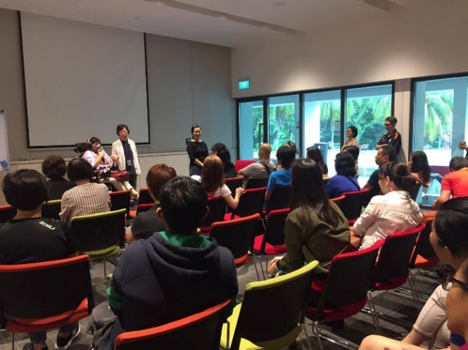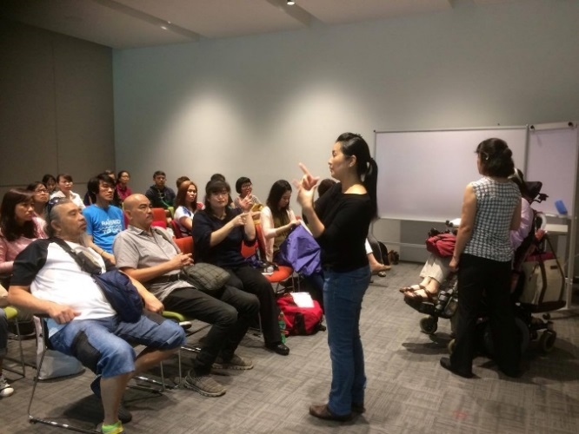

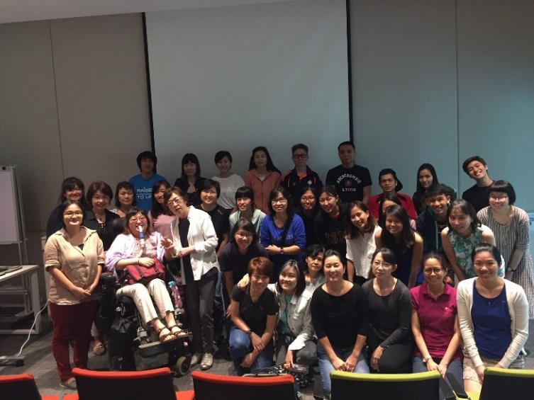

**1.2 シンガポールろう者協会訪問（Singapore Association of the Deaf）**

**1.2.1 団体概要・報告**

1955年に設立され、60年以上にわたり、ろう者、難聴者へのサービスを提供してきた。ろう文化と手話プログラム、コミュニティサービス（情報提供、カウンセリング、経済支援、就労支援、啓発活動、奨学金プログラム、法律相談など）、就学支援サービス（現在、シンガポールろう学校は閉鎖され、聴覚障害児は一般の学校へ通学している）、手話通訳者派遣、ノートテイカー派遣、補聴ケアサービス（補聴器のチェック、福祉機器の販売など）が含まれる。付属施設であるシンガポールろう学校は教育省のもとシンガポール手話を基本とし、英語を第2言語と位置づけるバイリンガル、多文化アプローチの学校として再開する計画を進めている。他に、職業訓練校がある。

シンガポールでは正確な障害者統計がなく、身体障害者手帳制度等もなく、聴覚障害者の人口は正確には分かっていないが、手話通訳者は6名（1名はパートタイム）しかおらず、手話通訳者の認知度も低いとのことである。

**1.3 通訳・介助員養成講座（導入）**

日程：平成29（2017）年3月5日

会場：シンガポールろう者協会（Singapore Association of the Deaf）

住所：227 Mountbatten Road, Singapore 397998

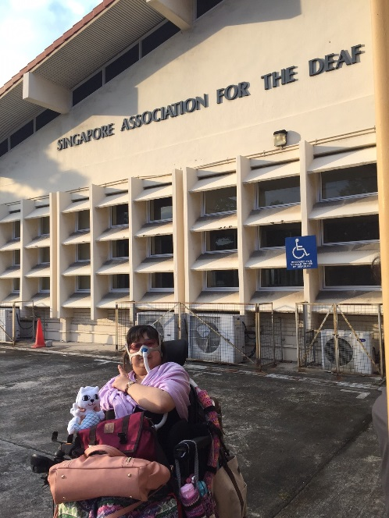

**1.3.1 背景**

通訳・介助員の存在は盲ろう者の自立と社会参加のみならず、生存には不可欠である。シンガポールでは盲ろう者を支援する制度はなく、支援方法も人材確保も模索している状態である。支援体制作りの基礎となる通訳・介助の役割、基本姿勢、技術に関して、日本の通訳・介助員養成講座の導入部分をシンガポールの状況にアレンジして行った。

現在把握している盲ろう者の支援に何らかの形で関わっている者（手話通訳者、ろう者、作業療法士、家族等）を対象に行った。そのため、参加者の大半がろう者であったり、手話を使ったコミュニケーションが可能であった。自分が接している盲ろう者にどう接したらいいのか具体的な場面を想定して学びたいという、参加目的が非常に明確な参加者が多かった。

**1.3.2 概要**

参加者は20名。通訳・介助員養成講座の中で、「盲ろう」についての概論的な部分の講義のあと、疑似体験（片眼は視野狭窄＋白内障、片眼は全盲）を取り入れて、移動介助演習と通訳技術演習を行った。解説を入れながらデモンストレーションを見たあと、2人1組で盲ろう者役と通訳・介助員役となり交代で、会場の室内およびシンガポールろう者協会キャンパス内で演習を行った。

移動介助演習では、狭いところを誘導する方法、障害物をよける、乗り越える、段差の上り下りなどを取り入れた。移動介助に関しては、盲ろう当事者が講師ではなく、日本から同行した通訳・介助員が担当する形をとった。

通訳技術演習では、シンガポール全体での手話通訳者が6名と非常に少ない現状を鑑みて、盲ろう者の支援にも、今後、ろうの通訳・介助員が中心になることが推測されることから、全体手話通訳を見て、それぞれの盲ろう者に合わせて通訳し直すリレー通訳を通訳技術演習の中心的な課題とした。時間の制約があり、全体手話通訳が伝える情報には含まれない、周囲の環境情報などを含める練習までは到達できなかったが、盲ろう当事者講師の福田氏が通訳・介助員から得た情報量と、講習生の伝えられた内容（質・量）と比較してもらうことで、盲ろう者に伝えるべき内容の判断、視覚情報の伝え方の工夫などの考察を深めることができた。

最後に講評と質疑応答の時間をできるだけ長く設けた。盲ろうであっても、個人差こそあるものの、適切な通訳・介助の介入、継続的関わりを続けていく中で、自己決定し、日常生活動作もおおよそ可能であることが理解してもらえたことで、今後の支援活動につなげてもらいたいと思う。

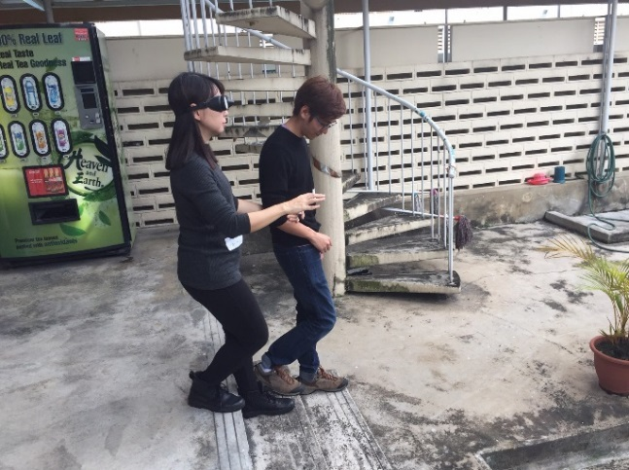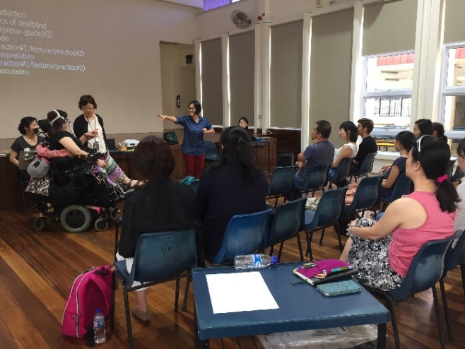

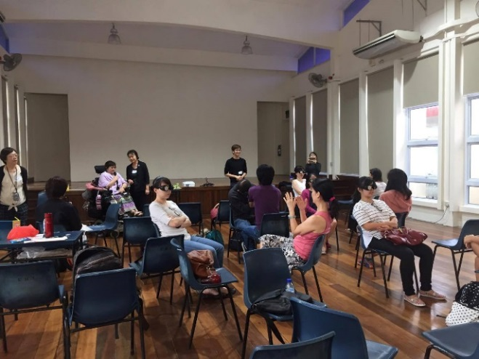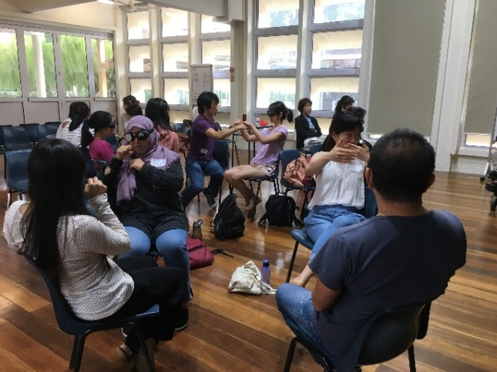

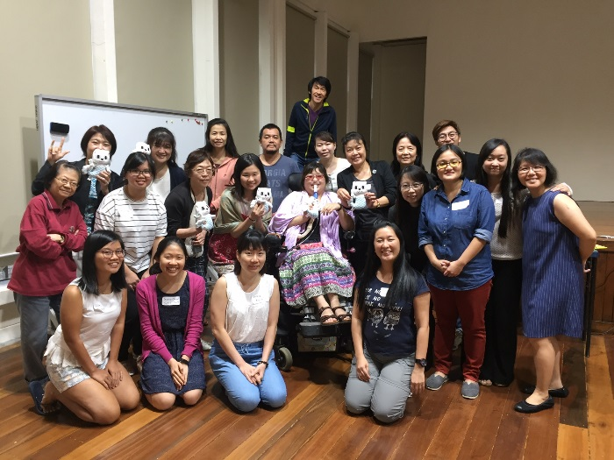

通訳・介助員養成講座

**1.4 Disabled Peoples’Association 訪問**

日程：平成29（2017）年3月6日

住所：1 Jurong West Central 2, #04-01 Jurong Point Shopping Centre,

Singapore 648886

**1.4.1 概要・背景**

シンガポールでは、多くの場合、障害関係団体はVWO(Volunteer Welfare Organization)という名称にて、社会サービスを提供している団体として政府の認定を受けている。障害者の福祉の向上を目指して、専門家やソーシャルワーカーを中心として運営している団体がほとんどであるが、障害当事者の権利擁護活動を、障害種別を問わず行っている団体がDPAである。障害当事者が団体の運営方針に主体性を持って関わり、国連障害者権利条約批准に関しても大きく貢献した。盲ろうという、視覚聴覚の重複障害者がシンガポールでどのような生活が可能なのか、どのような制度を利用できる可能性があるのか聞き取り調査を行った。事務局長のMarissa氏、事務局のJorain氏に交互にインタビューを行った。

**1.4.2 報告**

シンガポールではセイフティー・ネットは存在しない。しかし、様々なVWOが存在し、支援を受けることができる。チャリティーが背景にある団体も多い。政府からの手当はあるが、政府が定めた一定以下の低所得の障害者のみ対象となる。なので、低中間層が直面している問題である。低所得ラインを超える収入がある場合、自分自身で生計を立てていかなければならない。

DPAではイー・チャン・ロー氏以外の盲ろう者の存在は把握していない。障害者に関する正確な統計をシンガポール政府は把握しておらず、提供してくれない。VWOとして障害者を把握する方法としては、インフォーマルな方法であるが、障害を持っている者が申請できる無料交通パスを所持している障害者数を把握しているだけである。目に見えない障害の場合は、医者の診断書をSG-enbale(障害者のためのサービス提供機関)に持っていって無料交通パスが交付される。

ユニバーサルヘルスケア（国民皆保険など）としては、自動的にMedShield Lifeという保険に加入している。（参照：<https://medishieldlife.sg/>）

DPAでは、障害は、環境や人間関係などの関わりの中で発生するものだという社会的な視点の啓発活動を行っている。

シンガポールでは、年金や手当、福祉機器の支給など、公的な制度がなく、VWOも政府も就労支援に傾倒しがちである。日本の障害者雇用率の有効性についての意見交換をし、就労支援の中でも、就職先のマッチングについて意見を求められた。

シンガポールの障害者は、施設入所者はほとんどおらず、基本的に在宅で家族による支援の中で生活している。

**1.5 VWO及び政府機関との盲ろう者支援体制作りのためのネットワーク形成に**

**向けて　―ステークホルダーミーティング―**

日時：平成29（2017）年3月6日　14時～17時

住所：Handicaps Welfare Association: Jurong Branch Rehab & Training Centre 1 Jurong West Central 2 # 04-03, Jurong Point Shopping Centre Singapore 648886

参加者：Mr.Kan Tech San

(SAVH: Singapore Association for the Visual Handicap)

(<http://savh.org.sg/>)

Ms.Poh Sho Siam (SPD: Serving people with disability)

( http://www.spd.org.sg/)

Ms.Wai Hui Peng (NCSS: National Council of Social Services)

(https://www.ncss.gov.sg/)

Ms.Ang Chiew Geok (TCS: Touch Community Service)

(<http://www.touch.org.sg/>)

Ms.Jorain Ng (DPA: Disabled Peoples’Asociation)

(http://www.dpa.org.sg/

Ms.Lee Chan Loh (SADeaf: Singapore Association for the Deaf)

(<http://sadeaf.org.sg/>)

Mr.Lim Puay Tiak (ADF: ASEAN Disability Forum)

Ms.Akiko Fukuda (JDBA: Japan Deafblind Association)

**1.5.1 概要・背景**

シンガポールの盲ろう者に対しての支援を開始するために、現在サービス利用者に盲ろう者がいて、今後盲ろう者に関わる可能性のあるVWOの代表者（代理を含む）と、それらの団体をとりまとめている政府の機関であるNCSSの関係者の顔合わせ、及び、ネットワーク形成に向けて、盲ろう者の抱える課題について情報を共有し、今後の方向性を話し合った。

**1.5.2 議事次第**

・盲ろう者についての基本情報と日本の支援制度の紹介

・それぞれのVWOが直面している盲ろう者に関する問題について

・どのようなリソースが盲ろう者に可能なのか

・盲ろう者に関わるグループを立ち上げることについて

・ASEAN盲ろう者ネットワーク構築の可能性について

・その他の事項

**1.5.3 報告**

協議の結果、以下の4点が共有された

・盲ろう者の掘り起こしの方法を模索する必要がある

・小さくても構わないので盲ろう者が集まる機会を作る

・国際会議などに盲ろう者の代表者を送ること

・日本の盲ろう者協会の発足と展開の経緯について、全国盲ろう者協会から、福田氏らを通して経験を共有していく

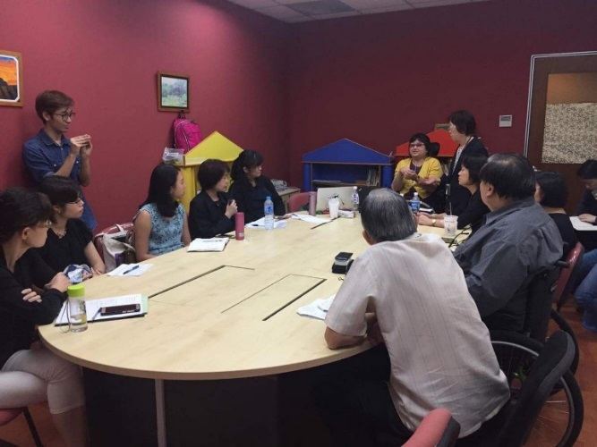

**1.6 福祉機器の視察及び意見交換**

**1.6.1 概要・背景**

SG-enbaleの中の障害者全般への福祉機器の情報センターが設置されており、専門支援員が配置されている。盲ろう者に対してどのような福祉機器が役に立つのか、また、福田氏が電動車いすを使用していることから、日本の車いすの支給プロセス、その他の日常生活用具、補装具の給付の仕組みなど、技術的な内容から、制度に関する内容まで幅広い意見交換が行われた。

**1.6.2 報告**

盲ろう者にとって点字の大切さ、点字ディスプレイ、携帯点字端末の使用の一例を盲ろう当事者である福田氏からデモンストレーションを通して説明した。シンガポールでは日本のように日常生活用具、補装具の支給制度はない。全額障害者、その家族が自費で負担することになる。点字ディスプレイ、意思伝達装置、電動車いすなどの高額なものは、募金、民間助成金、就労支援目的で雇用主が準備するなどは考えられる。適切なものを紹介しても、レンタルできる期間がほとんどないこと、メンテナンスにかかる経費などがその他の課題としてあげられた。

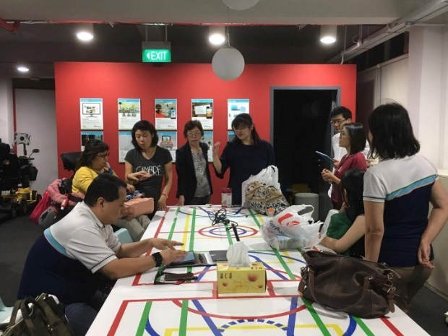

**1.7 シンガポール視覚障害者協会訪問**

**（Singapore Association of the Visually Handicapped）**

日程：平成29（2017）年3月7日

住所：47 Toa Payoh Rise Singapore 298104

**1.7.1 概要・背景**

シンガポール視覚障害者協会は、1951年に設立され、おおよそ3,700名の視覚障害者が登録されており、リハビリテーション、終了後も一貫したサービスを提供している。対象は子どもから高齢者まで年齢に関係なく受け入れている。主なサービスの内容は、ロービジョンクリニック、ロービジョンクリニックの分室の開室、盲学校の運営、日中活動、日常生活スキル向上訓練（マッサージ、アート活動、洗車、テレマーケティング、テレホンオペレーター、暗闇での食事体験を通した啓発活動）、視覚リハプログラム（ソーシャルワーク、歩行訓練、ADL訓練）、支援機器関係（用具の紹介と販売、点字出版、録音図書出版、権利擁護活動）などである。

**1.7.2 報告**

シンガポール視覚障害者協会では、ソーシャルワーカーの一人が盲ろうの利用者を担当している。現在、10名程度盲ろう者が登録されている。視覚障害者の教育、日常生活、日中活動、余暇活動、就労支援まで、一貫してサービスが提供されている。盲学校もあるが、一般の学校に通う視覚障害のある生徒が使う教科書の点訳、出版も行っている。視覚障害当事者スタッフも多く、英語の指点字で解説を受けることができた。

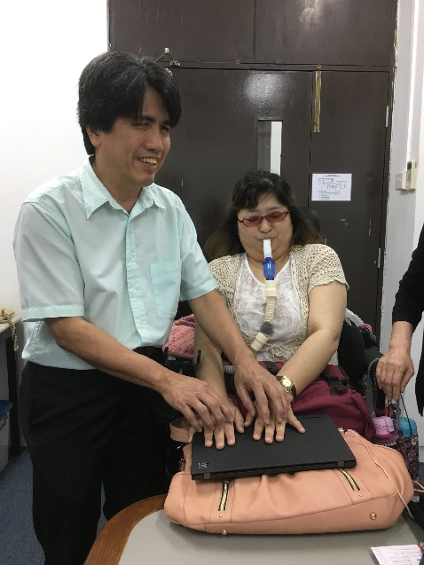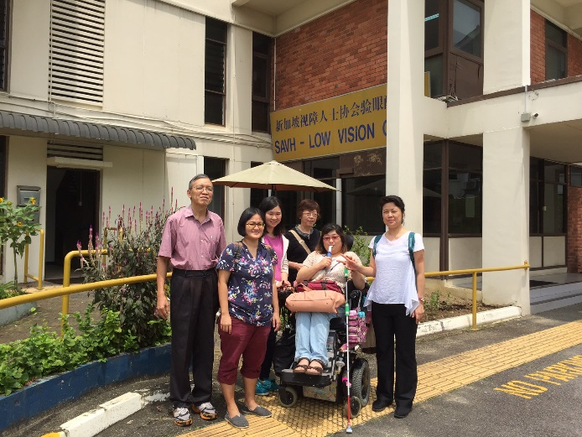

**1.8 盲ろう児宅訪問**

**1.8.1 概要**

先天性の盲ろう者（児）と関わり始めた知的障害関係団体（MINDS）より、担当している利用者について、どのような関わりや介入をしたらよいのか相談を受け、実際に自宅に伺い様子を観察することができた。

36歳の男性で、盲学校にも、ろう学校にも、受け入れを拒否されたまま家庭内で成長し、高齢となった両親が今後のことも考えて、地域のソーシャルワーカーに相談してから、知的障害者へのサービスを提供しているMINDSを紹介され、作業療法士、ソーシャルワーカーなど、チームアプローチで週に3回ほどのペースで関わり始めたとのことである。両親はシンガポールが建国前に教育を受けた年代であり、英語はできず、中国語しか分からないということで、家族からの聞き取りはできなかった。MINDSのスタッフ2名の関わり方を観察し、助言を行った。盲ろう児とその家族が孤立してしまう一例であった。

**２．タイ「アジア太平洋障害者の十年（2013-2022）」**

**ワーキンググループ第4セッション　出席**

**2.1 概要**

目的

本調査の目的は、国連アジア太平洋経済社会委員会（Economic and Social Commission for Asia and the Pacific、以下ESCAP）の主催・運営による会議「『アジア太平洋障害者の十年（2013-2022）』ワーキンググループ（以下ワーキンググループ）第４セッション」（2017年3月1日～2日、バンコク）への出席であった。ワーキンググループの背景、内容については後述する。ワーキンググループにはWFDBアジア地域代表者の福島智氏の代理として、福田暁子氏が出席した。

調査員

福田暁子（WFDB事務局長）

通訳・介助員およびヘルパー：杉浦節子、和田みさ、木内萌乃

城田さち（日英通訳者）

滝澤亜紀（日英通訳者）

日程

平成29（2017）年2月28日～3月3日（移動日を含む）

会場

United Nations Conference Centre (UNCC), Economic an Social Comission for Asia and the Pacific

**2.2. 背景**

2012年10月29日～11月2日、韓国インチョンにて行われた「『アジア・太平洋障害者の十年（2003-2012）』の実施に関する最終評価のためのハイレベル政府間会合」にて、「『アジア・太平洋障害者の十年（2013-2022）』閣僚宣言およびアジア太平洋障害者の『権利を実現する』インチョン戦略（以下、インチョン戦略）」が採択された。上記は2013年5月1日のESCAP総会決議69/13の中で承認された。

2013～2022年の10年の完全かつ効果的な実行を進めるために、ESCAP加盟国・準加盟国に対して専門的助言や支援を提供することを目的とした「『アジア太平洋障害者の十年（2013-2022）』ワーキンググループ」を設立することがこのインチョン戦略にて定められた。ワーキンググループへの委託事項は、付帯文書としてインチョン戦略に記載されている。

ワーキンググループは15のESCAP加盟国または準加盟国、15の市民社会団体（Civil Society Organisation、以下CSO）から構成され、任期は5年とする旨が定められた。WFDBは第一期のCSOメンバーとなった

**2.3　プログラム**

（1）開会式

（2）議長選出

（3）議事次第採択

（4）第3回ワーキンググループの決定事項及び提言の実施状況に関するレビュー

（5）アジア・太平洋障害者の十年（2013-2022）のレビュー

（6）2017年アジア・太平洋障害者の十年（2013-2022）ハイレベル政府間会合（Highlevel Intergovernmental Meetin: HLIGM）における中間レビューへの　　準備

（7）十年を推し進めるための資金調達のレビュー

（8）アジア・太平洋障害者の十年（2013-2022）の後半5年のワーキンググループの開催に関わる諸問題の検討

（9）その他の事項

（10）閉会式

**３．マレーシア盲ろう者支援プロジェクトフォローアップ**

日程：平成28（2016）年9月15日～10月14日

**3.1　概要・背景**

2016年度に行ったマレーシア盲ろう者支援プロジェクトのフォローアップも含めて、福田桂氏（盲ろう者）のインターンシップ活動のサポートを行った。

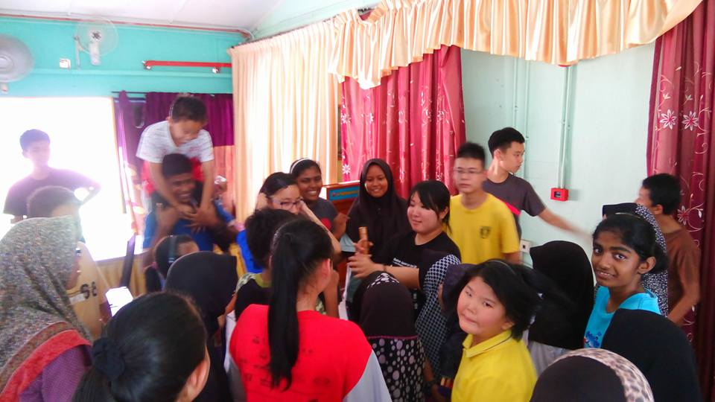**3.2　主な活動報告**

9月26日：盲ろう児と支援者との交流会および講演

10月5日・7日：ペナン島の盲学校、ろう学校にて　　教育関係者向けの講演、生徒との交流

10月10日・11日：「盲ろう者セミナー」指文字学習、

指点字学習、「通訳・介助」の講義。通訳・介助の講

義は福田暁子氏がスカイプを通して一部担当した。

**４．レソト盲ろう者支援プロジェクト事前調査**

日程：平成28（2016）年12月19日～12月21日

調査員氏名：宮本泰輔氏

**4.1　概要・背景**

レソト王国（以下、「レソト」）は、2002年から2006年にかけて課題別研修「南部アフリカ地域障害者の地位向上」（委託先：特定非営利活動法人DPI日本会議）に、合計5名を送り出し、研修コースの一部として自立生活（IL）の概念が伝えられてきた。2010年に行われた同帰国研修員へのフォローアップ調査を経て、2011年からは、より自立生活に焦点を当てた課題別研修「アフリカ障害者地域メインストリーミング研修」（委託先：同法人）が開始されたが、この研修にも、レソトから合計2名が送り出されている。

2006年度の研修参加者であるMs.Likopo Lesoetsaは、ろうの研修員として参加し、障害者の自立生活、障害者に関する政策、障害者運動、アクセシビリティなどを学んだ。帰国後も、所属組織であるLNFOD（Lesotho National Federation of the Disabled)やろう者組織で、日本で学んだことを活かして活動を継続していた。2015年ぐらいから視力も低下し始めたところ、日本で研修を受けた際から交流のある、社会福祉法人全国盲ろう者協会の福田暁子氏によるインターネットを通した継続的な支援や、LNFODの応援もあり、現在は、盲ろう者組織の設立を目指した活動も始めている。現在までに、5名の盲ろう者がMs.Lesoetsaによって見出されるとともに、2名の通訳・介助員が育成されている。

2012年度の研修参加者で、現在はLNFODのExecutive Directorを務めるMr.Nkhasi Sefuthiも、Ms.Lesoetsaの活動に賛同し、LNFODとしてもレソト盲ろう者協会設立に向けて協力していきたいと表明している。LNFODの傘下には、盲人組織とろう者組織の両方が加盟しており、それら組織のリソースを活用できることも期待される。

以上の内容で、JICAによるレソト盲ろう者支援プロジェクトの実行可能性を判断するために特定非営利活動法人DPI日本会議より、南アフリカにプロジェクト・マネージャーとして派遣されている宮本氏に協力を依頼し、現地訪問調査を行った。

**4.2　プログラム**

12月19日：LNFOD(Lesotho National Federation of the Disabled:

レソト身体障害者協会)訪問

12月20日：Ms.Lesoetsaの活動動向。農村部での障害児のメインストリーム事業、障害児の家庭訪問（4つの障害者団体が連携している事業にMs.Lesoetsaは、ろう協会のコーディネーターとして関わっている）。

12月21日：Ms. Lesoetsaの自宅訪問。聞き取り調査。

**4.3　報告**

（1）レソトの盲ろう者掘り起こしについて

現在までにろうコミュニティから1名、レソト視覚障害者連盟から2名、合計3名の盲ろう者を把握している。その他、首都のマセルに住んでいる盲ろう者もいれば、農村部を含む違う地域に住んでいる盲ろう者もいる。

（2）盲ろう者向けの通訳・介助員について

Ms.Lesoetsaは通訳・介助員を5名養成した。中心となって活動していた3名のうち1名が亡くなったので、現在2名になっているが、その2名も別のフルタイムの仕事をしている。あと数名は養成可能な人材がいる。

（3）盲ろう者を支援する団体について

・LNFOD (Lesotho National Federation of the Disabled)

・LNLVIP (Lesotho National League of the Visually Impaired Persons)

・NADL (National Association of the Deaf Lesotho)

（4）Possibility of Lesotho Deaf-Blind Association

・ろう協会が利用予定だった政府のオフィススペースがある。交渉次第では盲ろう者協会ができた後、使用可能かもしれない。

・交通手段はタクシーしかないが、タクシー業界と値下げの交渉が可能かもしれない。今後の具体的な計画やアクションについては、連絡を取り合いながらプロジェクト申請に向けて進めていく。

**５．ウズベキスタン指点字講習会**

平成29（2017）年2月25日（国内講師研修）

講師：大河内直之氏（全国盲ろう者協会登録通訳・介助員）

平成29（2017）年3月12日（指点字講習会）

講師：福地健太郎氏（JICA北海道国際センター研修業務課）

**5.1　概要・背景**

平成25（2013）年に行ったウズベキスタン盲ろう者支援プロジェクトのフォローアップの一つとして、JICA北海道国際センター研修業務課の福地健太郎氏のウズベキスタン訪問に合わせて、指点字講習会開催の支援を行った。福地氏は全盲であり、指点字の仕組みは理解があるが、盲ろう者のコミュニケーション方法の一つとして、指点字による通訳・介助の経験はない。そこで、国内において、指点字の通訳・介助員より福地氏に事前講師研修を行った。

また、研修会のみならず、盲ろう者、視覚障害者の日常生活に必要な点字器、点字タイプライター等を全国の盲ろう関係団体等に呼びかけ、寄贈した。

研修計画、実施はJICA青年海外協力隊として現地に派遣されている山名田氏、板倉氏の両名を中心に進められた。

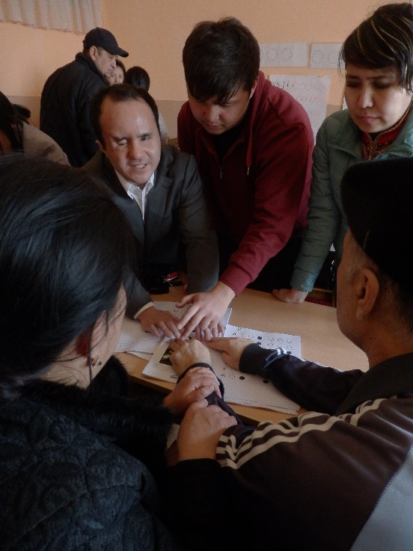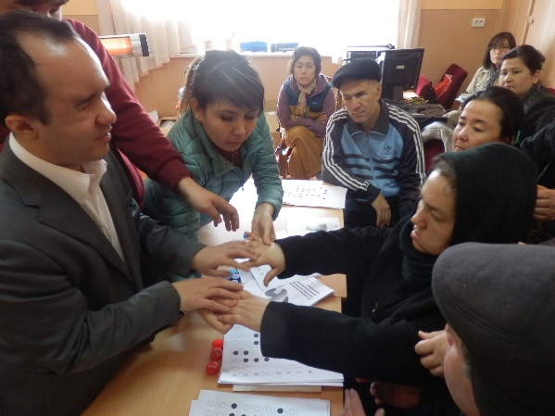

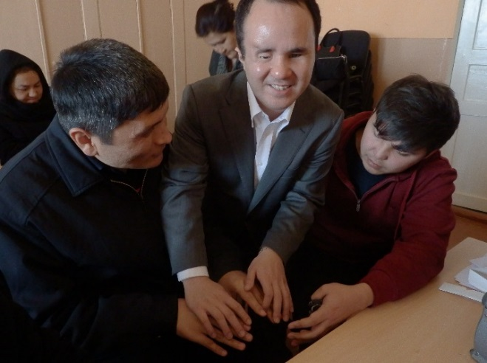

**６．その他会議等**

世界ろう連盟アジア地域会議参加および盲ろうについて発表

日程：平成28（2016）年10月14日～10月16日

会場：NTUC CENTRE. 1 Marina Boulevard Singapore 018989

発表者：福田桂氏

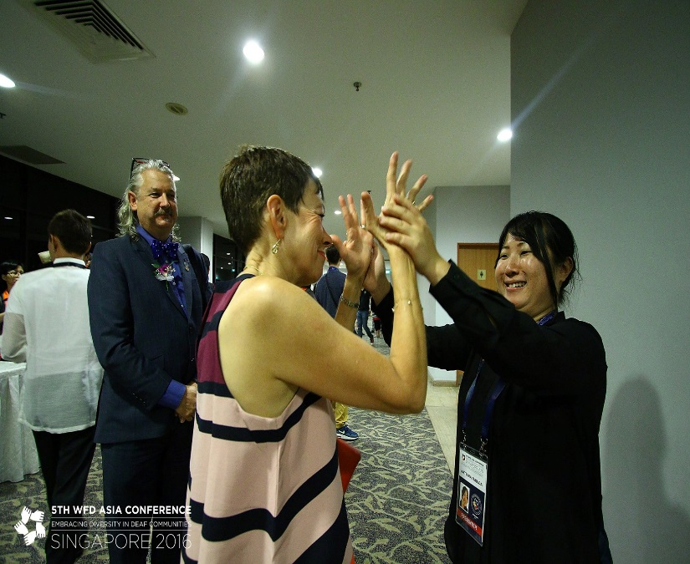

**参考資料**

***（参考資料①：ESCAP Report on the Fourth Session of the Working Group on the Asian and Pacific Decade of Persons with Disabilities, 2013-2022）***

**Report on the**

**Fourth Session of the Working Group on the**

**Asian and Pacific Decade of**

**Persons with Disabilities, 2013-2022**

**Bangkok**

**1-2 March 2017**

**Contents**

I. DECISIONS

II. RECOMMENDATIONS

III. PROCEEDINGS

A. Review of the implementation of decisions and recommendations emanating from the Third Session of the Working Group

B. Review of progress in the Asian and Pacific Decade of Persons with Disabilities, 2013-2022

C. Review of preparations for the 2017 High-level Intergovernmental Meeting on the Midpoint Review of the Asian and Pacific Decade of Persons with Disabilities (HLIGM)

D. Review of resource mobilization for Decade progress

E. Review of issues pertinent to the functioning of the Working Group for the 29second half of the Asian and Pacific Decade of Persons with Disabilities, 2013-2022

F. Other matters

IV. ORGANIZATION

A. Opening of the Fourth Session of the Working Group

B. Closing of the Session

C. Attendance

D. Election of officers

E. Agenda

Annex I

Annex II

**I. DECISIONS**

１． At its Fourth Session, held in Bangkok from 1 to 2 March 2017, the Working Group on the Asian and Pacific Decade of Persons with Disabilities, 2013-2022, decided on the following:

*Follow-up on the draft guidelines on the travel by air of persons with disabilities:*

a) The World Blind Union Asia-Pacific (WBUAP) and the World Federation of the Deafblind Asia and the Pacific (WFDBAP) (the drafting committee) will continue to develop and finalize the proposed draft guidelines on the travel by air of persons with disabilities. In doing so, specific efforts will be made to harmonize the guidelines with international standards of accessibility provisions for persons with disabilities as contained in the Manual on Access to Air Transport by Persons with Disabilities (Doc 9984) of the International Civil Aviation Organization. The draft guidelines should underscore that accessibility provisions, including services, must be comprehensive and dynamic in order to cover specific needs of persons with diverse disabilities arising when they travel by air. The draft guidelines should take into account the following timeframe:

・Working Group members to submit their personal experiences on barriers they face on air travel to the drafting committee by 31 March 2017;

・The drafting committee to circulate the revised guideline to Working Group members for finalization by 30 June 2017;

・Working Group members to provide comments to the revised guideline by 31 July 2017;

・The ESCAP secretariat to submit the completed Guidelines on the travel by air of persons with disabilities to ICAO and IATA by mid-August 2017;

b) The Government of India, as a member of the Working Group, will devise a plan for the Working Group to engage manufacturers of medical and mobility devices in discussions on meeting national and international standards of safety, noting the specific concerns related to transport by air of such devices by persons with disabilities. This plan will be devised by 31 March 2017.

*Preparations for the upcoming High-level Intergovernmental Meeting on the Midpoint Review of the Asian and Pacific Decade of Persons with Disabilities:*

c) The ESCAP secretariat will develop and circulate to the Working Group members for comments, an annotated outline of the outcome document for the High-level Intergovernmental Meeting, along with the Report on the Fourth Session of the Working Group, by 3 April 2017;

d) Working Group members will provide inputs on the annotated outline of the outcome document within two weeks following its circulation;

e) The ESCAP secretariat will develop a database on the results of the ESCAP survey on the midpoint review, and share the data as well as its findings with other stakeholders;

f) Working Group members will take steps, as appropriate, to follow up with Governments that have yet to submit their responses to the ESCAP survey on the midpoint review.

*Effectiveness of the Working Group:*

a) The ESCAP secretariat will submit the revised Midpoint Evaluation on the Effectiveness of the Working Group to the High-level Intergovernmental Meeting, along with the proposed changes to the Rules of Procedure of the Working Group, taking into account inputs emanating from the Fourth Session. The following points convey the envisioned structure and function of the Working Group in the second half of the Decade, with a view to better align it with its terms of reference and strengthen its outputs:

・Allow for remote participation of Working Group members in any forthcoming sessions if they are not able to participate in person;

・Frame discussions around implementation of the goals of the Incheon Strategy, focusing particularly on two goals within each session, among others;

・Working Group members may bring to sessions relevant inputs from other stakeholders, as appropriate;

・Share the outcomes of Working Group sessions including reports with all member States through channels such as ESCAP‘s Advisory Committee of Permanent Representatives (ACPR);

・Align the agenda of each Working Group session to support SDGs and CRPD as appropriate.

# II. RECOMMENDATIONS

2. The following recommendations also emerged from the discussions of the Working Group on the Asian and Pacific Decade of Persons with Disabilities, 2013-2022, at its Fourth Session:

*Intended outcomes of the High-level Intergovernmental Meeting on the Midpoint Review of the Asian and Pacific Decade of Persons with Disabilities:*

a) Working Group members reaffirmed that the outcome document should aim to provide tangible and actionable steps to address implementation shortfalls within the goals and targets laid out in the Incheon Strategy, with due consideration given to targets which have already been achieved in the first half of the Decade;

b) The ESCAP secretariat should get the feedback of Working Group members, Governments and other stakeholders for finalization of the draft outcome document before its submission to the High-level Intergovernmental Meeting. Government consultations may include those with an official intergovernmental body such as the ACPR.

c) Member States shall develop or harmonize national action plans in line with the outcome document to be adopted by the High-level Intergovernmental Meeting to improve implementation of and provide feedback on their progress of implementing the Incheon Strategy over the remaining years of the Decade. Member States should consider establishing a strong monitoring mechanism using both outcome and process indicators.

#### Support of on-going initiatives and projects

d) The ESCAP secretariat should take steps to encourage member States to adopt their national action plans related to the Incheon Strategy indicator project, and to share their experience on the Make the Right Real website;

e) Working Group members are requested to share experiences related to the development of a sign language dictionary, noting the Government of India’s current development of such a dictionary.

#### Funds to support the implementation of the Decade

f) The Make the Right Real Fund in the Republic of Korea should support participation of persons with disabilities at side events to be organized during the High-level Intergovernmental Meeting;

g) The Working Group recommends increased and diversified sources of contribution to the ESCAP Multi-donor Disability Trust Fund in the second half of the Decade, including through the High-level Intergovernmental Meeting.

# III. PROCEEDINGS

# A. Review of the implementation of decisions and recommendations emanating from the Third Session of the Working Group

３．The Session had before it the Report on the Third Session of the Working Group on the Asian and Pacific Decade of Persons with Disabilities, 2013-2022, Bangkok, 2-4 March 2016 (SDD/APDPD(3)/WG(4)/INF/4).

４．The following Working Group Government members made interventions: Bhutan,

Pakistan, and Republic of Korea. The following CSO members made interventions: AsiaPacific Development Center on Disabilities (APCD); Asia and Pacific Disability Forum (APDF); Asia-Pacific Disabled Persons Organizations United (APDPO); Digital Accessible Information System (DAISY) Consortium; Rehabilitation International Asia Pacific Region (RIAP); WBUAP; and WFDBAP. The International Civil Aviation Organization (ICAO) was a guest presenter.

５．The ESCAP secretariat briefed Working Group members on the status of implementation of decisions and recommendations emanating from the Third Session of the Working Group. DAISY noted that the Working Group mailing list had been developed and made available for use since the last session.

６．WBUAP briefed Working Group members on the status of draft guidelines for accessible air travel for persons with disabilities, developed together with WFDBAP and ASEAN Disability Forum (ADF). Several Working Group members suggested that revisions of the guidelines include considerations and reasonable accommodation for a diverse range of disabilities such as psychosocial disabilities, as well as personal experiences.

７．ICAO presented on international standards regarding transport of dangerous goods by air, with a particular focus on safe air travel with regards to motorized wheelchairs with lithium batteries. ICAO noted the potential for its own review of draft guidelines developed by the Working Group. ICAO also suggested that the guidelines be conveyed to the International Air Transport Association (IATA) in order to implement the recommendations on a more practical level. Several Working Group members noted the variance in the implementation of the standards across different countries and airlines, and shared with ICAO some challenges faced by persons with diverse disabilities related to reasonable accommodation when travelling by air. .

## B. Review of progress in the Asian and Pacific Decade of Persons with Disabilities, 2013-2022

８．The following Working Group Government members made interventions: Bhutan; 　　　　China; India; Indonesia; Japan; Mongolia; Pakistan; Republic of Korea; Russian Federation; and Thailand. The following CSO members made interventions: APCD; APDF; APDPO; DAISY; Inclusion International Asia-Pacific Regional Forum (IIAP); Pacific Disability Forum (PDF); RIAP; WBUAP; World Federation of the Deaf Regional Secretariat in Asia (WFDRSA); WFDBAP; and World Network of Users and Survivors of Psychiatry (WNUSP).

９．The ESCAP secretariat outlined its actions to support Incheon Strategy implementation including the Road Map actions, including enhancing Member States’ technical knowledge through national consultations on to identify data gaps and build statistical capacities of member States to establish a baseline dataset on Incheon Strategy indicators, publishing a set of good practices to support policymakers in promoting accessibility, and developing an e-learning tool to support policy and planning related to disability-inclusive disaster risk reduction. The ESCAP secretariat also noted its ongoing preparations for the High-level Intergovernmental Meeting, and work in international advocacy and awareness-raising on disability-inclusive development.

１０．Working Group members outlined their actions to support Incheon Strategy implementation. Several Working Group members noted recent national policies, strategies, surveys, as well as identification systems for persons with disabilities. They also noted their involvement in multilateral engagement initiatives with Governments, CSOs, and regional and international organizations. Working Group members mentioned specific disabilityinclusive development areas including employment opportunities, disaster risk reduction, and accessible communication and physical environments. RIAP noted the importance of further work on improving gender equality in disability-inclusive development.

１１．India noted their current plans to develop a sign language dictionary and invited Working Group members with relevant experience to offer best practices.

## C. Review of preparations for the 2017 High-level Intergovernmental Meeting on the Midpoint Review of the Asian and Pacific Decade of Persons with Disabilities (HLIGM)

１２．The following Working Group Government members made interventions: Bhutan; India; Japan; Mongolia; and the Republic of Korea. The following CSO members made interventions: APCD; APDF; APDPO; DAISY; PDF; RIAP; WFDBAP; and WNUSP.

１３．The Government of China, host of the upcoming HLIGM, noted that the Meeting would be held at the China Administration of Sports for Persons with Disabilities in Beijing from 27 November to 1 December 2017, and provided an overview of the history and significance of the venue.

１４．The ESCAP secretariat outlined the preparations and preliminary results of the ESCAP survey on the midpoint review for Governments, CSOs, and International organizations and development agencies. The Working Group discussed how the survey results should be used; noting that the data should be used as the basis to formulate the outcome document. Some Working Group members expressed interest in having the survey results made publicly available.

１５．The ESCAP secretariat briefed the Working Group members on the substantive focus and projected outcomes of the HLIGM, including: aligning the Incheon Strategy with the 2030 Agenda; sharing the results of the ESCAP survey on the midpoint review; and enhancing effective implementation of the Incheon Strategy for the remaining five years of the Decade. The secretariat also presented its preliminary ideas for the content of provisional agenda and midpoint review documents for the HLIGM.

１６．The ESCAP secretariat presented the structure for the outcome document, noting its intended inclusion of Ministerial Declaration and Action Plan sections. The secretariat also provided a timeline for the further development of the outcome document. Several Working Group members discussed ways member States and CSOs could provide inputs to the structure and content of the document, in particular to reflect the importance of accessible transport.

**D. Review of resource mobilization for Decade progress**

１７．The following Working Group Government members made interventions: Republic of Korea. The following CSO members made interventions: PDF and WNUSP.

１８．The ESCAP secretariat presented on the status of the ESCAP Multi-donor Trust Fund for the Asian and the Pacific Decade for Persons with Disabilities. The secretariat noted the importance of the Fund's specific focus on disability in the region and invited all countries to contribute to the Fund. One Working Group member expressed concern regarding the low number of member States that currently contribute to the Fund, and suggested developing strategies to enhance contributions.

１９．The Republic of Korea presented on recent actions taken by the Make the Right Real Fund, and invited interested parties to apply for funding in the 2017 cycle. The Republic of Korea noted that both CSOs and Governments can be funding recipients.

## E. Review of issues pertinent to the functioning of the Working Group for the second half of the Asian and Pacific Decade of Persons with Disabilities, 2013-2022

２０．The Session had before it the Draft Midpoint Evaluation on the Effectiveness of the Working Group on the Asian and Pacific Decade of Persons with Disabilities, 2013-2022, (SDD/APDPD (3)/WG (4)/1).

２１．The following Working Group Government members made interventions: Bhutan; India; Pakistan; Russian Federation; and Thailand. The following CSO members made interventions: APCD; APDF; APDPO; DAISY; IIAP; PDF; RIAP; WBUAP; and WFDPAP.

２２．The ESCAP Secretariat briefed the Working Group members on the draft Midpoint Evaluation on the Effectiveness of the Working Group on the Asian and Pacific Decade of Persons with Disabilities, 2013-2022. Some Working Group members expressed that the report was overly critical of the Working Group’s effectiveness and that much of the progress is not reported.

２３．Several Working Group members discussed ways to enhance sustainability of attendance at Working Group meetings, such as allowing remote participation. Some Working Group members expressed that meeting discussions should be focused on specific Incheon Strategy Goals and Indicators.

２４．The Working Group discussed ways to increase contributions from Governments and organizations outside of the Working Group, with some members suggesting to engage entities including but not limited to ACPR, CRPD Committee, and ASEAN Autism Network.

**F. Other matters**

２５．The Working Group reaffirmed the importance of linking Incheon Strategy implementation to the Sustainable Development Goals and CRPD.

２６．The Working Group members adopted the decisions and recommendations emanating from the Fourth Session of the Working Group.

# IV. ORGANIZATION

２７．The Working Group held its Fourth Session at the United Nations Conference Centre (UNCC) in Bangkok from 1 to 2 March 2017. In-kind support including accommodations for members with disabilities was provided by APCD.

## 

## A. Opening of the Fourth Session of the Working Group

２８．The Fourth Session was opened by Mr. Nagesh Kumar, Director, Social Development Division, ESCAP. In his statement, the Director noted the significance of the Fourth Session of the Working Group in the planning for the midpoint review of the Decade, as well as the future of the Working Group itself for the remainder of the Decade. He also expressed his gratitude to APCD for providing accessible accommodation facilities for participants at the Fourth Session with disabilities.

２９．Mr. Akiie Ninomiya, Executive Director, APCD, Bangkok, also made opening remarks to the Fourth Session. Mr Ninomiya reaffirmed the APCD’s collaboration with the ESCAP on the implementation of the Incheon Strategy, and cited an example in which persons with intellectual and psychosocial disabilities were now employed at an ESCAP cafeteria, and baked goods made by persons with disabilities were available at an ESCAP coffee shop.

## B. Closing of the Session

３０．Several Working Group members expressed their deep appreciation to the Chair and Vice-Chairs for leading the meeting’s discussion.

３１．The Working Group also thanked the ESCAP Secretariat for the servicing of the meeting.

３２．Closing statements were delivered by:

a. Mr. Nagesh Kumar, Director, Social Development Division, ESCAP; and

b. Mr. Phuntsho Wangyel, Chief Research Officer, Research and Evaluation Division, Gross National Happiness Commission, Royal Government of Bhutan

**C. Attendance**

３３．The following Working Group members attended the Fourth Session (Annex II): The Governments of Bhutan; China; India; Indonesia; Japan; Malaysia; Mongolia; Pakistan; Republic of Korea; Russian Federation; and Thailand; as well as; Asia and Pacific Disability Forum; Asia-Pacific Development Center on Disability; Asia-Pacific DPO United; DAISY Consortium; Inclusion International Asia-Pacific; Pacific Disability Forum; Rehabilitation International Asia Pacific Region; World Blind Union Asia-Pacific; World Federation of the Deaf Regional Secretariat in Asia and the Pacific; World Federation of the Deafblind Asia and the Pacific; and World Network of Users and Survivors of Psychiatry Asia-Pacific.

Regrets were sent by the Governments of Bangladesh, Fiji, and Kiribati; as well as ASEAN Disability Forum and Central Asia Disability Forum.

３４．The following Observers attended the Fourth Session (Annex II): Christian Blind Mission and Community-based Rehabilitation Asia-Pacific Network.

Regrets were sent by the Government of Myanmar and ASEAN Autism Network.

３５．International Civil Aviation Organization attended as a guest presenter, and Japan International Cooperation Agency and Nippon Foundation attended as unofficial observers.

## D. Election of officers

３６．The Working Group at its Fourth Session elected the following as Bureau officers:

Chair: Mr. Phuntsho Wangyel (Bhutan)

Vice-Chair: Mr. Akiie Ninomiya (APCD)

Vice-Chair: Ms. Zarena Binti Shuib (Malaysia)

## E. Agenda

３７．The Working Group at its Fourth Session adopted the following agenda:

(1) Opening of the Fourth Session of the Working Group

(a) Opening addresses

(b) Election of officers

(c) Adoption of the agenda

(2) Review of the implementation of decisions and recommendations emanating from the Third Session of the Working Group

(3) Review of progress in the Asian and Pacific Decade of Persons with Disabilities, 2013-2022

(4) Review of preparations for the 2017 High-level Intergovernmental Meeting on the Midpoint Review of the Asian and Pacific Decade of Persons with Disabilities (HLIGM)

(a) Dates and venue of the 2017 HLIGM

(b) ESCAP survey on the midpoint review of the Asian and Pacific Decade of Persons with Disabilities, 2013-2022

(c) Consideration of the provisional agenda and other background documents for the HLIGM

(d) Discussion on the draft outline of the outcome document

(5) Review of resource mobilization for Decade progress

(a) ESCAP Multi-donor Trust Fund for the Asian and the Pacific Decade of Persons with Disabilities

(b) Republic of Korea’s Make the Right Real Fund

(6) Review of issues pertinent to the functioning of the Working Group for the second half of the Asian and Pacific Decade of Persons with Disabilities, 2013-2022

(7) Other matters

(8) Closing of the Session

# Annex I

**Composition of the Working Group on the Asian and Pacific Decade of Persons with Disabilities, 2013-2022**

First 5 years of the Decade (2013-2017)

### Members

**15 Government Members:**

1. Bangladesh
2. Bhutan
3. China
4. Fiji
5. India
6. Indonesia
7. Japan
8. Kiribati and Samoa share a seat (Samoa: first 2.5 years;　　　　　　　 Kiribati: second 2.5 years)
9. Malaysia
10. Mongolia
11. Pakistan
12. Philippines
13. Republic of Korea
14. Russian Federation
15. Thailand

**15 Civil Society Organization (CSO) Members:**

1. Asia and Pacific Disability Forum
2. Asia-Pacific Development Center on Disability
3. ASEAN Disability Forum
4. Asia-Pacific DPO United
5. Central Asia Disability Forum
6. South Asian Disability Forum
7. Pacific Disability Forum
8. Disabled People’s International Asia-Pacific
9. Inclusion International Asia-Pacific
10. World Blind Union Asia-Pacific
11. World Federation of the Deaf Regional Secretariat in Asia and 　　　the Pacific
12. World Federation of the Deafblind Asia and the Pacific
13. World Network of Users and Survivors of Psychiatry
14. Digital Accessible Information System (DAISY) Consortium
15. Rehabilitation International Asia Pacific Region

### Observers

**1 Government Observer:**

1. Myanmar

**3 CSO Observers:**

１．ASEAN Autism Network

２．Christian Blind Mission

３．Community-based Rehabilitation Asia-Pacific Network

_________________

# Annex II

**List of participants**

**Governments**

### Bhutan

**Representative**

Mr. Phuntsho Wangyel, Chief Research Officer, Research and Evaluation Division, Gross National Happiness Commission, Royal

Government of Bhutan, Thimphu

Mr. Tashi Dorji, Senior Research Officer, Research and Evaluation Division,

Gross National Happiness Commission, Royal Government of Bhutan, Thimphu

**China**

#### Representative

Ms. Nie Jing, Deputy Director, Division of Liaison, Department of

International Affairs, China Disabled Persons' Federation, Beijing

### India

**Representative**

Mr. Awanish Kumar Awasthi, Joint Secretary, Department of Disability Affairs, Ministry of Social Justice and Empowerment, New

Delhi

### Indonesia

**Representative**

Mr. Marjuki, Director General of Social Rehabilitation, Ministry of Social Affairs, Jakarta

**Alternate**

Mr. Dodi Taresa Handahandoro, Programme Planner of Social

Rehabilitation, Ministry of Social Affairs, Jakarta

**Japan**

**Representative**

Mr. Hitoshi Kozaki, Head of International Organization Department and Deputy Permanent Representative to ESCAP, Embassy of Japan, Bangkok

#### Alternate

　 Mr. Toru Adachi, First Secretary and Deputy Permanent

Representative of Japan to ESCAP, Embassy of Japan, Bangkok

Mr. Satoshi Yoshida, First Secretary and Alternate Permanent

Representative to ESCAP, Bangkok

**Malaysia**

#### Representative

Ms. Zarena Binti Shuib, Senior Principal Assistant, Ministry of

Women, Family & Community Development, Putrajaya, Malaysia

**Mongolia**

#### Representative

Ms. Batdulam Tumenbayar, Director, Division for Development of Persons with Disabilities, Department of Population Policy Implementation and Coordination,

Ministry of Population

Development and Social Protection, Ulaanbaatar

**Alternate**

Ms. Boloroo Buyanjargal, Officer, Population Development Department's Division for Development of People with Disabilities, Ministry of Labour and Social Protection, Ulaanbaatar

Ms. Bolortsetseg Khureesuren, Bilateral Cooperation Specialist,

Ministry of Labour and Social Protection, Ulaanbaatar

**Pakistan**

**Representative**

Ms. Aqsa Nawaz, Counsellor and Deputy Permanent Representative to ESCAP, Embassy of the Islamic Republic of Pakistan, Bangkok

**Republic of Korea**

**Representative**

Mr. In-cheol Kang, Director, Division of Rights Promotion for Persons with Disabilities, Ministry of Health and Welfare, Seoul

#### Alternate

Ms. Sumin Kim, Deputy Director, Division of Rights Promotion for Persons with Disabilities, Ministry of Health and Welfare, Seoul

Mr. Kwang-hee Kim, Deputy Director, Korea Disabled People's

Development Institute, Seoul

Ms. Mirim Ji, Programme Officer, Korea Disabled People's Development Institute, Seoul

Ms. Sangeun Cho, Associate Research Fellow, Korea Disabled People's

Development Institute, Seoul

**Russian Federation**

#### Representative

Ms. Anna Gusenkova, Deputy Director, Department of Disabled

People Affairs, Ministry of Labour and Social Protection, Moscow

#### Alternate

Ms. Antonina Gladkova, Adviser, Department of Legal and

International Affairs, Ministry of Labour and Social Protection,

Moscow

Ms. Natalia Karmazinskaya, Third Secretary and Assistant Permanent

Representative to ESCAP, Embassy of the Russian Federation,

Bangkok

**Thailand**

#### Representative

Ms. Jenjeera Boonsombat, Social Development Officer, National Office for Empowerment of Persons with Disabilities, Ministry of Social Development and Human Security, Bangkok

**Civil society organizations**

### Asia and Pacific Disability Forum (APDF)

**Representative**

Mr. Kyeongtaek Byeon, Chair, APDF, Seoul

#### Alternate

Mr. Sungmin Jo, APDF Secretariat, Seoul

Mr. Youngin Cho, APDF Secretariat, Seoul

### Asia-Pacific Development Center on Disability (APCD)

**Representative**

Mr. Akiie Ninomiya, Executive Director, APCD, Bangkok

**Alternate**

Mr. Ryuhei Sano, General Manager, APCD, Bangkok

Ms. Nongluck Kisorawong, Administrative Manager, APCD, Bangkok

Mr. Jasper Rom, Community Development Manager, APCD, Bangkok

Ms. Duangnarumol Dokruk, Information and Knowledge Management Manager, APCD, Bangkok

Mr. Watcharapol Chuengcharoen, Chief, Office of Network Secretariat,

APCD, Bangkok

Ms. Lynette Lee Corporal, Chief, Information and Knowledge

Management, APCD, Bangkok

Ms. Nongnuch Maytarjittipun, Executive Secretary to Executive

Director, APCD, Bangkok

Mr. Hironobu Shibuya, Special Advisor, Nippon Foundation, c/o

APCD, Bangkok

### Asia-Pacific DPO United

**Representative**

Mr. Dae-song, Kim, Chairman, Asia-Pacific DPO United, Seoul

### Digital Accessible Information System (DAISY) Consortium

#### Representative

Mr. Dipendra Manocha, Developing Countries Coordinator, DAISY

Consortium, New Delhi

**Alternate**

Mr. Hiroshi Kawamura, Board Member, DAISY Consortium, Tokyo

### Inclusion International Asia-Pacific Regional Forum (IIAP)

#### Representative

Mr. Matthew David Corner, Asia Pacific Representative, Wellington Pacific Disability Forum (PDF)

**Representative**

Mr. Setareki Seru Macanawai, Chief Executive Officer, PDF, Suva

### Rehabilitation International Asian-Pacific Region (RIAP)

#### Representative

Ms. Ye-Ja Lee, Chair, Rehabilitation International Asia Pacific Region,

Seoul

#### Alternate

Mr. Asish Kumar Mukherjee, Former RIAP/President - NMO RI India,

Rehabilitation International, Director General, Indian Spinal Injuries

Centre, New Delhi

Ms. Myung-Hwa You, Secretary General, KSRPD, APDF, RIAP,

Rehabilitation International Asia Pacific Region, Seoul

### World Blind Union Asia-Pacific (WBUAP)

#### Representative

Ms. Michiko Tabata, President, World Blind Union Asia Pacific Region, Tokyo

### World Federation of the Deaf Regional Secretariat in Asia (WFDRSA)

**Representative**

Mr. Yasunori Shimamoto, Regional Director, WFDRSA, Tokyo

**Alternate**

Ms. Kaweng U, Deputy Regional Director, WFDRSA, Macao

### World Federation of the Deafblind Asia (WFDBA)

#### Representative

Ms. Akiko Fukuda, Secretary General, World Federation of the

Deafblind, Tokyo

### World Network of Users and Survivors of Psychiatry (WNUSP)

#### Representative

Mr. Oh Yong Kweon, Deputy Board Member, WNUSP, Seoul

**Observers (official)**

**CBR Asia-Pacific Network**

Mr. Ghulam Nabi Nizamani, Chairperson, CBR, Sanghar, Pakistan

### CBM Central East Asia Regional Office

Ms. Vu thi Tuyet Mai, Programme Officer, CBM Country Coordination Office, Hanoi

**Observers (unofficial)**

**Asia and Pacific Disability Forum (APDF)**

Mr. Abraham Hsieh, APDF, Seoul

Mr. Il Yung Lee, APDF, Seoul

Ms. Younghee Yang, APDF, Seoul

### Japan International Cooperation Agency (JICA)

Ms. Yoko Isobe, JICA Expert on Survey/Analysis and Coordination,

Project for Promoting Social Participation of Persons with Disabilities,

Ministry of Labour and Social Protection, Ulaanbaatar

### Nippon Foundation

Ms. Kanako Shinden, Project manager, Nippon Foundation, Tokyo

_________________

**Support personnel for accessibility Language interpreter**

Ms. Sachi Shirota, Japanese-English Language Interpreter, WFDBA,

Tokyo

Ms. Aki Takizawa, Japanese-English Language Interpreter, WFDBA,

Tokyo

### Meeting assistant

Ms. Trish Grant, Director of Advocacy, IHC New Zealand

Incorporated, Inclusion International, Wellington

**Personal assistant**

Ms. Moeno Kiuchi, Personal Assistant to Ms. Akiko Fukuda, Secretary

General, World Federation of the Deafblind, Tokyo

Ms. Reena Lee, Personal Assistant to Mr. Il Yung Lee, APDF, Seoul

Ms. Eileen Yeh-Lin Lu, Personal Assistant to Mr. Abraham Hsieh,

APDF, Seoul

Ms. Ana Pickering Macanawai, Personal Assistant to Mr. Setareki Seru

Macanawai, Chief Executive Officer, Pacific Disability Forum, Suva

### Sign language interpreter

Mr. John Xandre Baliza, Sign Language Interpreter, WFDRSA, Tokyo

Mr. Samuel Kai Mun Chew, Sign Language Interpreter, WFDRSA, Tokyo

### Tactile sign language interpreter

Ms. Setsuko Sugiura, Interpreter-Guide for the Deafblind (Japanese

Tactile Sign Language), WFDBA, Tokyo

Ms. Misa Wada, Interpreter-Guide for the Deafblind (Japanese Tactile

Sign Language), WFDBA, Tokyo

_________________

**United Nations Secretariat Economic and Social Commission for Asia and the Pacific** **Social Development Division (SDD)**

Mr. Nagesh Kumar, Director, SDD

Mr. Patrik Andersson, Chief, Sustainable Socioeconomic

Transformation Section, SDD

Ms. Cai Cai, Chief, Gender Equality and Social Inclusion Section

(GESIS), SDD

Ms. Aiko Akiyama, Social Affairs Officer, GESIS, SDD

Mr. Dong Ho Kim, Social Affairs Officer, GESIS, SDD

Mr. Chol O Han, Associate Social Affairs Officer, GESIS, SDD

Mr. Tyler Kretzschmar, Consultant, GESIS, SDD

Ms. Angela Burns, Intern, GESIS, SDD

***（参考資料②：Draft Midpoint Evaluation on the Effectiveness of the Working Group on the Asian and Pacific Decade of Persons with Disabilities, 2013-2022 (Revised)* 本稿執筆段階ではまだドラフトであり最終文書ではないことに留意。*）***

**Summary**

The Working Group on the Asian and Pacific Decade of Persons with Disabilities, 2013–2022, is an ESCAP advisory mechanism composed of representatives from 15 governments and 15 civil society organizations. Its membership for the first half of the Decade was endorsed by the Commission at its 69th session in 2013. The ESCAP secretariat serves as the secretariat of the Working Group. Established by the Incheon Strategy to “Make the Right Real” for Persons with Disabilities in Asia and the Pacific, the Working Group is tasked with providing technical advice and support to ESCAP members and associate members in their full and effective implementation of the Incheon Strategy during the Asian and Pacific Decade of Persons with Disabilities, 2013–2022.

The Working Group held its first session in 2014 where it adopted its own Rules of Procedure and has been convened three more times annually up to 2017. In the course of its work, it has adopted numerous decisions and recommendations, which seek to address and improve its functioning, support disability inclusion in the 2030 Agenda and Sustainable Development Goals and action for the implementation of the Incheon Strategy, develop new disability-inclusive guidelines and provide inputs to the midpoint review process.

This document gives an overview of the background, achievements and effectiveness of Working Group in the first half of the Decade, and invites the High-level Intergovernmental Meeting to provide guidance on the future of the Working Group for the second half of the Decade, from 2018-2022.

**Contents**

I. INTRODUCTION

II. SUMMARY OF ORGANIZATION AND PROCEEDINGS OF

THE FOUR SESSIONS OF THE WORKING GROUP

III. DECISIONS, RECOMMENDATIONS AND MAJOR

ACHEIVEMENTS BY THE WORKING GROUP

IV. EFFECTIVENESS OF AND CHALLENGES FACED BY THE WORKING GROUP

V. PROPOSED AMENDMENTS TO THE RULES OF PROCEDURE OF THE WORKING GROUP

VI. CONCLUSION

Annex I: Terms of Reference of the Working Group on the Asian and Pacific Decade of Persons with Disabilities, 2013-2022

Annex II: Composition of and attendance to the Working Group on the Asian and Pacific Decade of Persons with Disabilities, 2013-2022

Annex III: Proposed Rules of Procedure of the Working Group on the Asian and Pacific Decade of Persons with Disabilities, 2013-2022, for the second half of the Decade

**Ⅰ．INTRODUCTION**

1. The High-level Intergovernmental Meeting on the Final Review of the Implementation of the Asian and Pacific Decade of Disabled Persons, 2003-2012, held at Incheon, Republic of Korea, from 29 October to 2 November 2012, adopted the Ministerial Declaration on the Asian and Pacific Decade of Persons with Disabilities, 2013-2022, and the Incheon Strategy to “Make the Right Real” for Persons with Disabilities in Asia and the Pacific.
2. The Commission, at its 69th session, through its resolution 69/13 on the Implementation of the Ministerial Declaration on the Asian and Pacific Decade of Persons with Disabilities, 2013-2022, and the Incheon Strategy to “Make the Right Real” for Persons with Disabilities in Asia and the Pacific,[1] of 1 May 2013, endorsed the above-mentioned Ministerial Declaration, and the Incheon Strategy.
3. Paragraph 30 of the Incheon Strategy notes the establishment of a regional working group on the Asian and Pacific Decade of Persons with Disabilities, 2013–2022, with the objective to provide technical advice and support to members and associate members, to promote the full and effective implementation of the Decade, 2013-2022.
4. The Terms of Reference of the Working Group, contained in the Incheon Strategy, calls on members of the Working Group to provide advice on: reviews of Decade progress concerning the implementation of the Ministerial Declaration and the Incheon Strategy, including regional and subregional cooperation in this regard; research on the evolving situation of persons with disabilities in the region; and outreach to diverse disability groups at the national and local levels.[2]
5. The Terms of Reference also stipulates that the Working Group should be composed of 30 members; 15 from ESCAP members and associate members and 15 from civil society organizations (CSOs).[3] The High-level Intergovernmental Meeting noted the interest expressed by 17 ESCAP members, as well as 19 CSOs to serve on the Working Group for the first term covering the period 2013-2017. The Commission, at its 69th session endorsed the membership through its decision 69/4 on the Membership of the Working Group on the Asian and Pacific Decade of Persons with Disabilities, 2013-2022.[4]
6. The Working Group has been convened annually four times in regular sessions between 2014 and 2017. Reports on each of the four sessions contain decisions and recommendations adopted, alongside a summary of the proceedings. This report provides a summary of the Working Group sessions held thus far, and discusses the Working Group’s effectiveness in line with its objectives and functions. It also requests the High-level Intergovernmental Meeting on the Midpoint Review of the Asian and Pacific Decade of Persons with Disabilities, 2013-2022, to provide guidance on the future of the Working Group.

**Ⅱ．SUMMARY OF ORGANIZATION AND PROCEEDINGS OF THE FOUR SESSIONS OF THE WORKING GROUP**

1. The First Session of the Working Group was hosted by the Government of the Republic of Korea and held in Incheon, Republic of Korea, from 25 to 26 February 2014.[5]
2. The Session was formally opened and chaired by the Assistant Minister, Office for Social Welfare Policy, Ministry of Health and Welfare, Republic of Korea. It was attended by representatives of 14 ESCAP members, 14 CSOs and 2 observers.[6]
3. The Session discussed: (i) Consideration and adoption of the draft Rules of Procedure of the Working Group; and (ii) Review and adoption of the preliminary draft ESCAP road map for the implementation of the Incheon Strategy.
4. The Session made five decisions, including adopting the Rules of Procedure, and 11 recommendations, including those related to the draft road map, the inclusion of disability in the post-2015 development agenda, fund mobilization, and networking and e-communication, among others.
5. The Second Session of the Working Group was hosted by the Government of India and held in New Delhi, India, from 2 to 3 March 2015.[7]
6. The Session was formally opened by the Minister of Social Justice and Empowerment, and chaired by the Secretary, Department of Empowerment of Persons with Disabilities, Ministry of Social Justice and Empowerment, Government of India. It was attended by representatives of 13 ESCAP members, all 15 CSOs and 3 observers.[8]
7. The Session discussed: (i) Review of the implementation of decisions and recommendations emanating from the First Session of the Working Group; (ii) Review of progress in the Asian and Pacific Decade of Persons with Disabilities, 2013-2022; (iii) Consideration of preparations for the midpoint review of the Asian and Pacific Decade of Persons with Disabilities in 2017; and (iv) Review of resource mobilization for Decade progress.
8. The Session made four decisions, including those on the submission of the Incheon Strategy by the Government of India to the United Nations secretariat in New York to be used as a reference for the development of the disability-inclusive indicators of the Sustainable Development Goals and the establishment of an e-taskforce to facilitate the creation of an online platform for Working Group members to share information, among others. It also adopted seven recommendations, noting that Working Group members should contact national civil aviation authorities in their respective countries to obtain information on their policies and rules regarding passengers with disabilities, including issues regarding batteries used for motorized wheelchairs, and that the ESCAP secretariat should undertake activities to support the regional implementation of the Incheon Strategy.
9. The Third Session of the Working Group was hosted by the Government of Thailand and held in Bangkok, Thailand from 2 to 4 March 2016.[9]
10. The Session was formally opened by the Permanent Secretary, Ministry of Social Development and Human Security, and chaired by the Director General, Department of Empowerment of Persons with Disabilities, Ministry of Social Development and Human Security, Government of Thailand. It was attended by representatives of 14 ESCAP members, 14 CSOs and 5 observers.[10]
11. The Session discussed: (i) Review of the implementation of decisions and recommendations emanating from the Second Session of the Working Group; (ii) Review of progress in the Asian and Pacific Decade of Persons with Disabilities, 2013-2022; (iii) Consideration of preparations for the midpoint review of the Asian and Pacific Decade of Persons with Disabilities in 2017; and (iv) Review of resource mobilization for Decade progress.
12. The Session made 13 decisions, including those related to the establishment of a tool for information sharing within the Working Group, the drafting of guidelines regarding passengers travelling by air with motorized wheelchairs, other mobility aids and medical devices, and preparations for the 2017 High-level Intergovernmental Meeting, among others. It also made five recommendations, related to sharing information of Working Group sessions with non-members, adopting national action plans on disability data collection, and supporting the midpoint review process by identifying CSO focal points on disability in each country, among others.
13. The Fourth Session of the Working Group was held in Bangkok, Thailand from 1 to 2 March 2017, hosted by the ESCAP secretariat, with in-kind support by Asia-Pacific Development Center on Disability (APCD).
14. The Session was formally opened by Mr. Nagesh Kumar, Director, Social Development Division, ESCAP. It was attended by representatives of 11 ESCAP members, 11 CSOs and 5 observers.
15. The Session discussed: (i) Review of the implementation of decisions and recommendations emanating from the Third Session of the Working Group; (ii) Review of progress in the Asian and Pacific Decade of Persons with Disabilities, 2013-2022; (iii) Review of preparations for the 2017 High-level Intergovernmental Meeting on the Midpoint Review of the Asian and Pacific Decade of Persons with Disabilities (HLIGM); (iv) Review of resource mobilization for Decade progress; and (v) Review of issues pertinent to the functioning of the Working Group for the second half of the Asian and Pacific Decade of Persons with Disabilities, 2013-2022.
16. The Session made seven decisions, including those related to the editing and finalizing of the draft guidelines regarding passengers with disabilities travelling by air, preparations for the 2017 High-level Intergovernmental Meeting with a focus on the review process of the draft outcome document, and improving the effectiveness of the Working Group, including its functions and procedures among others. It also made seven recommendations, related to intended outcomes of the High-level Intergovernmental Meeting, including the outcome document, support of on-going initiatives and projects and funds to support the implementation of the Decade.

**Ⅲ．DECISIONS, RECOMMENDATIONS AND MAJOR ACHEIVEMENTS BY THE WORKING GROUP**

1. Throughout its four sessions, the Working Group adopted a total of 29 decisions and 30 recommendations.
2. Of these 59 decisions and recommendations, 22 are directly related to the internal functioning of the Working Group, and 37 have implications for matters outside of the Working Group.
3. Of these 59 decisions and recommendations, 27 call for action by Working Group members, and 28 call for action by the ESCAP secretariat, while 2 call for action by both Working Group members and the ESCAP secretariat, and 2 are targeted at all ESCAP members and associate members.
4. In line with the decisions and recommendations emanating from each of the four sessions, the Working Group made following achievements:

*Procedure and internal communication*

1. Adopted its own Rules of Procedure;[11]
2. Launched an inter-sessional e-mail-based group for Working Group members to exchange good practices and information on the implementation of the Incheon Strategy, including reporting on road map actions and supporting the preparatory process toward the 2017 High-level Intergovernmental Meeting;

*Advocacy for disability inclusion in the post-2015 development agenda*

1. Advocated for disability inclusion in the 2030 Agenda for Sustainable Development, including submission of the Incheon Strategy to the Statistics Division of the United Nations Department of Economic and Social Affairs (DESA) to be used as a reference for the development of the disability-inclusive indicators of the Sustainable Development Goals (SDGs);

*Support of national and regional action for the implementation of the Incheon Strategy*

1. Developed and adopted a road map for the implementation of the Incheon Strategy,[12] which was later endorsed by the Commission at its 70th session through its Decision 70/23;[13]
2. Submitted, in advance of its sessions, annual reports on Incheon Strategy implementation of Working Group members, aligned with the road map, including policies and rules of national civil aviation authorities regarding passenger with disabilities;
3. Expressed its continued support for the mobilization of funding contributions for a range of technical cooperation activities in support of Incheon Strategy implementation, including continued utilization of the ESCAP Multi-donor Trust Fund for the Asian and the Pacific Decade of Persons with Disabilities;[14]

*Developing disability-inclusive guidelines*

1. Gave input on the publication “Disability Inclusive Meetings: An Operational Guide”, to support the provision of reasonable accommodation and accessibility for persons with disabilities in formal meeting settings;[15]
2. Drafted the guidelines regarding the needs of and considerations for passengers with diverse disabilities travelling by air. This was done by a drafting committee, which leveraged insight and expertise from various Working Group members;

*Inputs for the midpoint review process*

1. Supported the development and distribution of the ESCAP survey on the midpoint review to collect baseline data for the Incheon Strategy indicators, as well as gave input on the draft outcome document in preparation for the 2017 High-level Intergovernmental Meeting;

**Ⅳ．EFFECTIVENESS OF AND CHALLENGES FACED BY THE WORKING GROUP**

1. The Working Group is envisioned as a unique mechanism in which an equal number of member States and civil society organizations from Asia and the Pacific are represented and exercise the same rights. It seeks to provide a platform to exchange views and propose actions on the implementation of the Incheon Strategy, and embody inclusive participation and decision-making as called for by the Incheon Strategy and the Convention on the Rights of Persons with Disabilities (CRPD).
2. The envisioned equal participation between member States and civil society organizations, as well as inclusive participation and decision-making, are well reflected in the Working Group throughout its four sessions. Its function as a platform for collaboration to support implementation of the Incheon Strategy is reflected through the drafting of guidelines regarding the needs of and considerations for passengers with disabilities travelling by air.
3. Despite these achievements, the Working Group faces a number of challenges in light of its initial objective and function as prescribed in the Terms of Reference and procedures:

*Objective*

1. With the intended objective to provide technical advice and to support member States in their implementation of the Incheon Strategy, beyond contributions to the publication “Disability Inclusive Meetings: An Operational Guide” and the guidelines regarding the needs of and considerations for passengers with disabilities travelling by air, the Working Group has not elaborated on ways and means to identify support that may be required by member States who are not members of the Working Group.

*Functions*

1. With the intended function to advise member States on the review of the implementation of the Ministerial Declaration and the Incheon Strategy, and promote regional and subregional cooperation, the Working Group has not been able to produce tangible and specific advice beyond the ESCAP survey on the midpoint review.
2. The roadmap was created as a result of the discussion and input of the Working Group, but member States outside of the Working Group (as well as members themselves) have had very little knowledge of this document, indicating that outreach to member States has been insufficient.
3. With the intended function to conduct research on the evolving situation of persons with disabilities in the region, the Working Group has not taken any action to explore or report on the situation of persons with disabilities beyond annual reports on Incheon Strategy implementation within their own domains.
4. With the intended function to provide outreach to diverse disability groups at the national and local levels, the Working Group adopted a recommendation to communicate information and proposals from Working Group sessions to non-members of the Working Group. However, there has been neither coordinated effort nor tangible action to so do.

*Procedures*

1. While an inter-sessional e-mail-based group was created to promote discussions between the Working Group members, the mechanism has hardly been utilized by anyone.
2. The Working Group, through its own developed and adopted Rules of Procedure, prescribes self-financed participation by all members including persons with disabilities. This resulted in an issue of sustainable participation. The first three sessions were hosted by member States, but the last session did not have a host government to provide financial assistance. This resulted in a relatively lower attendance.
3. According to 4.3 in the Rules of Procedure, in the event that a member does not attend two consecutive sessions (regular or ad hoc), that member shall relinquish its seat on the Working Group. Two members were therefore required to relinquish its membership.
4. While the Working Group’s membership was fixed during the first half of the Decade, individual participants who represented member States or civil society organizations often changed. When representatives could not travel from their capitals, some member States were represented by diplomats working at their Embassy in Bangkok. Therefore, the level of institutional knowledge on the Working Group and engagement of these members differed between sessions, and posed challenges to effective communication and maintaining momentum for achieving the decisions and recommendations adopted by the Working Group.

**Ⅴ．PROPOSED AMENDMENTS TO THE RULES OF PROCEDURE OF THE WORKING GROUP**

1. In light of the challenges identified above, the Working Group at its Fourth Session made the following suggestions:
2. Allow for remote participation of Working Group members in any forthcoming sessions if they are not able to participate in person;
3. Frame discussions around implementation of the goals of the Incheon Strategy, focusing particularly on two goals within each session, among others;
4. Working Group members may bring to sessions relevant inputs from other stakeholders, as appropriate;
5. Share the outcomes of Working Group sessions including reports with all member States through channels such as ESCAP‘s Advisory Committee of Permanent Representatives (ACPR);
6. Align the agenda of each Working Group session to support SDGs and CRPD as appropriate.
7. To implement the suggestions above, amendments are required to be made to the current Rules of Procedure for the Working Group. Proposed amendments are inserted Annex III: Proposed Rules of Procedure of the Working Group on the Asian and Pacific Decade of Persons with Disabilities, 2013-2022, for the second half of the Decade.

**Ⅵ．CONCLUSION**

1. Noting the achievements, effectiveness and challenges associated with the Working Group, the High-level Intergovernmental Meeting on the Midpoint Review of the Asian and Pacific Decade of Persons with Disabilities, 2013-2022 is invited to express its views on the relevance and functioning of the Working Group for the second half of the Decade (2018-2022).
2. In pursuance of the Terms of Reference of the Working Group,[16] the second announcement of interest in serving on the Working Group shall take place at the High-level Intergovernmental Meeting. ESCAP members and associate members and civil society organizations are invited to express their interest in members of the Working Group in the period 2018-2022. The proposed membership will be submitted to the consideration of the Commission at its seventy-fourth session, in 2018, for the final decision on the composition of the Working Group for the second term.

**Annex I: Terms of Reference of the Working Group on the Asian and Pacific Decade of Persons with Disabilities, 2013-2022**

*Objective*

1.The objective of the proposed regional working group on the Asian and Pacific Decade of Persons with Disabilities is to provide technical advice and support to members and associate members, to promote the full and effective implementation of the Decade, 2013-2022.

*Functions*

2.In pursuance of the objective stated in paragraph 1 above, the working group shall advise members and associate members on the following:

(a) Reviews of Decade progress, especially concerning the implementation of the Ministerial Declaration on the Asian and Pacific Decade of Persons with Disabilities, 2013-2022, and the Incheon Strategy to “Make the Right Real” for Persons with Disabilities in Asia and the Pacific;

(b) Regional and subregional cooperation to advance implementation of the Ministerial Declaration and the Incheon Strategy;

(c) Research on the evolving situation of persons with disabilities in the Asia-Pacific region;

(d) Outreach to diverse disability groups at the national and local levels, and networking.

*Membership*

3.The working group shall be composed of representatives of ESCAP members and associate members, as well as civil society organizations operating at the regional and subregional levels in Asia and the Pacific.

4.The tenure of working group members shall be five years, with the possibility of extension for another five years.

5.All ESCAP members and associate members shall be eligible to serve on the working group.

6.The working group should be composed of 30 members, taking into account gender equality: 15 from members and associate members and 15 from civil society organizations. At least half of the seats allocated for civil society organizations should be guaranteed for persons with disabilities and emerging civil society organizations.

7.A civil society entity that meets the following criteria shall be eligible to serve as a member of the working group: (a) operate at the regional and/or subregional levels in Asia and the Pacific; (b) be an organization or network that represents, supports and/or promotes the interests of persons with diverse disabilities; (c) has technical expertise relevant to advancing the implementation of the Ministerial Declaration and the Incheon Strategy.

8.The announcement of interest by individual ESCAP members and associate members, and civil society organizations, in serving as members of the working group shall take place at the High-level Intergovernmental Meeting on the Final Review of the Implementation of the Asian and Pacific Decade of Disabled Persons, 2003-2012, Incheon, Republic of Korea, from 29 October to 2 November 2012.

9.The proposed composition of the working group shall be submitted to the Commission at the session that immediately follows the High-level Intergovernmental Meeting, for a final decision. Thus, the Commission at its sixty-ninth session, in 2013, will make the final decision on the composition of the working group for the first term, spanning the period 2013-2017. The second announcement of interest in serving on the working group shall take place at the High-level Intergovernmental Meeting convened on the occasion of the midpoint of the Decade (2017). The Commission at its seventy-fourth session, in 2018, will make the final decision on the composition of the working group for the second term, spanning the period 2018-2022.

10.ESCAP members and associate members, civil society organizations, in particular, organizations of persons with disabilities, subregional intergovernmental agencies, United Nations agencies, development cooperation agencies and development banks can attend meetings of the working group as observers.

*Rules of procedure*

11.The working group shall adopt its own rules of procedure.

*Secretariat*

12.The ESCAP secretariat shall serve as the secretariat of the working group. It shall, inter alia, disseminate working group documentation in accessible formats.

_______________

**Annex II: Composition of and attendance to the Working Group on the Asian and Pacific Decade of Persons with Disabilities, 2013-2022**

**Composition for the first 5 years of the Decade (2013-2017)**

**Members**

**15 Government Members:**

1. Bangladesh
2. Bhutan
3. China
4. Fiji
5. India
6. Indonesia
7. Japan
8. Kiribati and Samoa share a seat (Samoa: first 2.5 years; Kiribati: second 2.5 years)
9. Malaysia
10. Mongolia
11. Pakistan
12. Philippines
13. Republic of Korea
14. Russian Federation
15. Thailand

**15 Civil Society Organization (CSO) Members:**

1. Asia and Pacific Disability Forum
2. Asia-Pacific Development Center on Disability
3. ASEAN Disability Forum
4. Asia-Pacific DPO United
5. Central Asia Disability Forum
6. South Asian Disability Forum
7. Pacific Disability Forum
8. Disabled People’s International Asia-Pacific
9. Inclusion International Asia-Pacific
10. World Blind Union Asia-Pacific
11. World Federation of the Deaf Regional Secretariat in Asia and the Pacific
12. World Federation of the Deafblind Asia and the Pacific
13. World Network of Users and Survivors of Psychiatry
14. Digital Accessible Information System (DAISY) Consortium
15. Rehabilitation International Asia Pacific Region

**Observers**

**1 Government Observer:**

1. Myanmar

**3 CSO Observers:**

1. ASEAN Autism Network
2. Christian Blind Mission
3. Community-based Rehabilitation Asia-Pacific Network

**List of ESCAP members and CSOs that expressed interest in membership in the Working Group at the High-level Intergovernmental Meeting on the Final Review of the Implementation of the Asian and Pacific Decade of Disabled Persons, 2003-2012**

(i) *Members and associate members of ESCAP*: (1) Bangladesh; (2) Bhutan; (3) China; (4) Fiji; (5) India; (6) Indonesia; (7) Japan; (8) Kiribati; (9) Malaysia; (10) Mongolia; (11) Myanmar; (12) Pakistan; (13) Philippines; (14) Republic of Korea; (15) Russian Federation; (16) Samoa; and (17) Thailand.

(ii) *Civil society organizations*: (1) ASEAN Autism Network; (2) ASEAN Disability Forum; (3) Asia-Pacific Development Center on Disability; (4) Asia-Pacific DPO United; (5) Asia Pacific Disability Forum; (6) Central Asian Disability Forum; (7) Christian Blind Mission; (8) Community-based Rehabilitation Asia-Pacific Network; (9) Commitments, India; (10) DAISY Consortium; (11) Disabled Peoples’ International Asia-Pacific; (12) Inclusion International Asia Pacific Regional Forum; (13) Pacific Disability Forum; (14) Rehabilitation International Asia Pacific Region; (15) South Asian Disability Forum; (16) World Blind Union Asia-Pacific; (17) World Federation of the Deaf Regional Secretariat for Asia and the Pacific; (18) World Federation of the Deafblind Asia and the Pacific; and (19) World Network of Users and Survivors of Psychiatry Asia-Pacific.

**Attendance at the first four sessions of the Working Group**

X: *present* --: *absent*

|  |  |  |  |  |
| --- | --- | --- | --- | --- |
| **ESCAP Government members** | **First Session** | **Second Session** | **Third Session** | **Fourth Session** |
| Bangladesh | X | X | -- | -- |
| Bhutan | X | X | X | X |
| China | X | X | X | X |
| Fiji | X | -- | X | -- |
| India | X | X | X | X |
| Indonesia | X | X | X | X |
| Japan | X | X | X | X |
| Kiribati / Samoa | -- | X | X | -- |
| Malaysia | X | -- | X | X |
| Mongolia | X | X | X | X |
| Pakistan | X | X | X | X |
| Philippines | X | X | X | -- |
| Republic of Korea | X | X | X | X |
| Russian Federation | X | X | X | X |
| Thailand | X | X | X | X |
| **Civil Society Organizations** | **First Session** | **Second Session** | **Third Session** | **Fourth Session** |
| Asia and Pacific Disability Forum | X | X | X | X |
| Asia-Pacific Development Center on Disability | X | X | X | X |
| ASEAN Disability Forum | X | X | X | -- |
| Asia-Pacific DPO United | X | X | X | X |
| Central Asia Disability Forum | X | X | -- | -- |
| South Asian Disability Forum | X | X | X | -- |
| Pacific Disability Forum | X | X | X | X |
| Disabled People’s International Asia-Pacific | X | X | X | -- |
| Inclusion International Asia-Pacific | X | X | X | X |
| World Blind Union Asia-Pacific | X | X | X | X |
| World Federation of the Deaf Regional Secretariat in Asia and the Pacific | X | X | X | X |
| World Federation of the Deafblind Asia and the Pacific | -- | X | X | X |
| World Network of Users and Survivors of Psychiatry | X | X | X | X |
| Digital Accessible Information System (DAISY) Consortium | X | X | X | X |
| Rehabilitation International Asia Pacific Region | X | X | X | X |
| **Official Observers** | **First Session** | **Second Session** | **Third Session** | **Fourth Session** |
| Myanmar | -- | -- | -- | -- |
| ASEAN Autism Network | -- | -- | X | -- |
| Christian Blind Mission | X | X | -- | X |
| Community-based Rehabilitation Asia-Pacific Network | X | -- | X | X |
| **Additional Observers and Guests** | **First Session** | **Second Session** | **Third Session** | **Fourth Session** |
| Samarthyam | -- | X | -- | -- |
| Disability Rights Promotion International | -- | X | -- | -- |
| Japan International Cooperation Agency | -- | -- | X | X |
| Korea Disabled People’s Development Institute | -- | -- | X | X |
| UNICEF | -- | -- | X | -- |
| Nippon Foundation | -- | -- | -- | X |
| International Civil Aviation Organization | -- | -- | -- | X |

_______________

**Annex III: Proposed Rules of Procedure of the Working Group on the Asian and Pacific Decade of Persons with Disabilities, 2013-2022, for the second half of the Decade**

*Note: This includes the proposed amendments to the Rules of Procedure of the Working Group for the second half of the Decade, as reflected in paragraph 16.*

***Rule 1***

**Sessions**

The following principles shall apply as regards the convening of sessions of the Working Group:

1.1. Regular sessions of the Working Group shall be held annually.

1.2. Sessions shall be convened by the secretariat of the United Nations Economic and Social Commission for Asia and the Pacific (hereinafter “ESCAP”).

1.3. The ESCAP secretariat may also convene ad hoc sessions of the Working Group, if requested by more than half of the members of the Working Group in consultation with the Chairperson.

1.4. The ESCAP secretariat shall transmit a written invitation to each regular session of the Working Group, together with a provisional agenda, at least sixty work days in advance of the start of the session, and, whenever practicable, a written invitation to each ad hoc session, together with a provisional agenda, at least thirty work days before the start of each session.

1.5. An invitation to a session shall be sent to the senior official designated to represent the member of the Working Group at the correspondence address conveyed to the ESCAP secretariat for official correspondence. Responses to invitations shall be sent via electronic mail to the ESCAP secretariat within the requested time frame, that is, no later than thirty work days before a regular session and fifteen work days before an ad hoc session.

1.6. All formal correspondence addressed to government members of the Working Group shall be copied to the permanent representatives of member States that are members of the Working Group, in accordance with existing rules and procedures of ESCAP, through official channels of communication. Furthermore, formal correspondence shall be addressed to the functional titles, and not to the personal names, of those designated to serve as standing members of the Working Group.

***Rule 2***

**Venue**

2.1. Working Group sessions shall ordinarily be held at the Headquarters of ESCAP in Bangkok.

2.2. Members of the Working Group may make known at a session their offers to host subsequent sessions at an alternate venue.

2.3. A session may be held away from ESCAP Headquarters in Bangkok, provided that the Working Group member representing a member State or civil society organization that proposes to host the session covers the additional costs to be incurred as a result of the change in venue, in accordance with a cost estimate prepared by the ESCAP secretariat.

***Rule 3***

**Secretariat**

The ESCAP secretariat shall serve as the Secretariat of the Working Group.

***Rule 4***

**Participation**

4.1. Members of the Working Group shall participate in its sessions on a self-financing basis.

4.2. For meetings held away from ESCAP Headquarters, the host government or host organization may consider defraying the cost of travel, accommodation and subsistence of Working Group members.

4.3. If members of the Working Group are unable to participate in its sessions in person for justifiable reasons, they will request for remote participation via electronic mail to the ESCAP secretariat no later than twenty working days before a regular session and ten work days before an ad hoc session. Arrangement for remote participation shall take into the importance of technologies accessible to persons with diverse disabilities to be used at the venue.

4.4. In the event that a member does not attend two consecutive sessions (regular or ad hoc), that member shall relinquish its seat on the Working Group.

***Rule 5***

**Reasonable Accommodation**

Every effort shall be made to provide reasonable accommodation to representatives of Working Group members.

***Rule 6***

**Conduct of business**

6.1. The Working Group shall at each session elect a Chairperson, as well as two Vice Chairpersons, one from a government and one from a civil society organization, who would serve until the next regular session.

6.2. The Chairperson may, if required, appoint a task force composed of interested Working Group members to undertake in-depth review of specific issues for consideration by the Working Group.

6.3. Before a proposal is agreed upon, the Chairperson shall call on the ESCAP secretariat to provide a statement on the financial implications of the proposal.

6.4. Decisions and recommendations of the Working Group shall, in principle, be made by consensus. In the event that consensus cannot be reached, decisions shall be made by a majority of the Working Group members present at a session and voting.

***Rule 7***

**Voting**

7.1. Each Working Group member shall have one vote.

7.2. The Working Group shall normally vote by a show of hands. If the Chairperson requests a roll-call, it shall be taken in the English language alphabetical order of the names of Working Group members, that is, the names of the member States followed by the names of the civil society organizations.

***Rule 8***

**Agenda**

8.1. The provisional agenda for each regular session of the Working Group shall be drawn up by the ESCAP secretariat. Working Group members may suggest amendments to the agenda in writing in advance of the session or orally and in writing at the start of the session itself.

8.2. The provisional agenda of each session of the Working Group shall frame discussions around implementation of the goals of the Incheon Strategy, focusing particularity on two goals, among others, pre-determined at the previous session.

8.3. The provisional agenda shall align the Incheon Strategy with the 2030 Agenda’s Sustainable Development Goals and the Convention on the Rights of Persons with Disabilities, as appropriate.

8.4. Working Group members may bring to sessions relevant resource persons and inputs from other stakeholders, as appropriate with the consent of the Group in advance of the session.

8.5. The provisional agenda for the regular session shall include:

(1) Opening of the session and adoption of the agenda.

(2) Election of the Chairperson and two Vice Chairpersons.

(3) Review of the implementation of decisions emanating from the previous session of the Working Group.

(4) Review of progress in the Asian and Pacific Decade of Persons with Disabilities, 2013-2022, particularly concerning the following[17]:

(a) National-level implementation of the Ministerial Declaration on the Asian and Pacific Decade of Persons with Disabilities, 2013-2022, and the Incheon Strategy to “Make the Right Real” for Persons with Disabilities in Asia and the Pacific, including the implementation of the outcome document of the 2017 High-level Intergovernmental Meeting on the Midpoint Review, with a focus on two of the Incheon Strategy goals;

(b) Regional and subregional cooperation to advance implementation of the Ministerial Declaration and the Incheon Strategy, with a focus on two of the Incheon Strategy goals;

(c) Research on the evolving situation of persons with disabilities in the Asia-Pacific region;

(d) Outreach to diverse disability groups, including women with disabilities, at the national and local levels, and networking.

(5) Review of resource mobilization for Decade progress:

(a) ESCAP trust fund for the Asian and Pacific Decade of Persons with Disabilities, 2013-2022;

(b) Make the Right Real Fund of the Republic of Korea;

(c) Other funding sources.

(6) Date and venue of the next regular session.

(7) Two goals of the Incheon Strategy to be focused on at the next regular session.

(8) Other matters.

8.6. The provisional agenda for ad hoc sessions of the Working Group shall be drawn up by the ESCAP secretariat, as required.

***Rule 9***

**Language**

The sessions of the Working Group shall be conducted in English and documentation shall be issued in English.

***Rule 10***

**Report on the sessions of the Working Group**

10.1. The draft report on each session of the Working Group shall be prepared by the ESCAP secretariat and transmitted to Working Group members within thirty work days of the end of a session. Working Group members shall transmit any comments on the draft report to the ESCAP secretariat within thirty work days of receiving the draft report. The ESCAP secretariat shall transmit the final report to Working Group members and observers as soon as possible, and in no event later than ninety work days after the session.

10.2. The report of each session of the Working Group shall, among others, include its decisions and/or recommendations. This decisions and/or recommendations shall be discussed and agreed upon during the respective session of the Working Group.

10.3. Unless otherwise mandated, until the end of the Decade the outcomes of the sessions of the Working Group and other Working Group endeavours shall be incorporated in the triennial reports of the Executive Secretary to the Commission on the implementation of Commission resolution 69/13 on Implementation of the Ministerial Declaration on the Asian and Pacific Decade of Persons with Disabilities, 2013-2022, and the Incheon Strategy to “Make the Right Real” for Persons with Disabilities in Asia and the Pacific.

10.4. The ESCAP secretariat shall share the outcomes of the sessions of the Working Group with member States through channels including, but not limited to, the Advisory Committee of Permanent Representatives.

10.5. Official documents for the sessions of the Working Group shall be made available in accessible formats, as required. A digital version of the official documents for the sessions of the Working Group shall be made available in universally accessible formats, such as EPUB3 or DAISY.

***Rule 11***

**Representation and Tenure**

11.1. The tenure of Working Group members, namely member States and civil society organizations, shall be five years spanning the period 2018 to 2022, bearing in mind Rule 4.4. The Commission, at its seventy-fourth session in 2018, shall make the final decision on the composition of the Working Group for the second term spanning the period 2018-2022.

11.2. Each member State and civil society organization represented on the Working Group[18] shall inform the ESCAP secretariat in writing of the name of its senior representative, and confirm the address, including electronic mail address, to which official correspondence concerning the Working Group should be sent.

11.3. In the event that the designated representative of a Working Group member, whether a member State or a civil society organization, is unable to continue her/his duty on the Working Group, that member State or civil society organization shall designate another senior official to represent it in the Working Group.

11.4. Any member or associate member of ESCAP interested in attending a session in an observer capacity and on a self-financing basis shall express such interest in writing to the ESCAP secretariat well in advance of the convening of a session.

11.5.A civil society organization of an ESCAP member or associate member that is interested in attending a session of the Working Group, in an observer capacity and on a self-financing basis, must meet the eligibility criteria specified in paragraph 7 of the Terms of Reference of the Working Group. Such a civil society organization shall express its interest in writing to the ESCAP secretariat well in advance of the convening of a session.

11.6. Subregional intergovernmental agencies, United Nations agencies, development cooperation agencies and development banks may be invited to attend Working Group sessions in an observer capacity and on a self-financing basis.

11.7. Any member of the Working Group may contribute the technical inputs of subject specialists to facilitate consideration of a matter on which a decision or recommendation would be required of the Working Group. The ESCAP secretariat may also invite such specialists to facilitate recommendations by the Working Group. An invitation to a specialist to provide technical inputs to a session in an observer capacity shall be limited to that specific session and such an observer shall not participate in decision making by the Working Group.

***Rule 12***

**Entry into force and amendments to these**

**Rules of Procedure**

12.1. These Rules of Procedure shall enter into force on the date of their adoption by the Working Group.

12.2. Any aspect of these Rules of Procedure may be amended or overridden during a Working Group session, provided the amendment or exception is consistent with the spirit and intent of the Asian and Pacific Decade of Persons with Disabilities, 2013-2022, and agreed to by the Working Group.

_______________

***（参考資料③：ウズベキスタン指点字講習会プロポーザル）***

**指点字講習会**

目的：ウズベキスタン国内において、盲ろう者の支援はまだ確立されていないばかりか、当事者間においても徐々にその必要性が認知されつつある段階である。盲／ろうの当事者も盲ろう者に対してどのような支援の可能性があるのか、まだ明確に見出すことができていないとの相談がJVに寄せられた。それが正当なニーズであると判断したことから、本講習会は、盲ろう者／視覚障害者／聴覚障害者の当事者組織におけるリーダーを対象に、日本で誕生した盲ろう者の代表的なコミュニケーション方法である「指点字」の基本的な方法を習得するために開催する。

日　時：2017年3月12日（日）9時― 12時

|  |  |  |  |
| --- | --- | --- | --- |
| 9:00 | 9:05 | 9:15 | 12:00 |
| 集合 | 開会  挨拶：オリム会長 | 講座 | 閉会  挨拶：ろう者文化センター代表 |

※修了後、「世界の笑顔のために」プログラムで供与を受けた点字器と点字タイプライターの寄贈式を行う予定。

場　所：タシケントろう者文化センター（板倉隊員の配属先）

講　師：JICA　北海道国際センター　研修業務課　福地健太郎　氏（全盲）

参加者：シルダリア州視覚障害者協会およびタシケントろう者文化センターの会員

およそ5～10名

進行係：山名田・板倉・通訳ボランティア

通　訳：(1) 日本語→現地語：現地人のボランティアに依頼予定

　　　　(2) 現地語→ロシア語手話：手話通釈者へ依頼予定

配付物：Пщддержка слепоглухих людей в их передвижении（ロシア語資料）

Бармоқ брайл ҳақида ўрганамиз（ウズベク語資料）

＊板倉・山名田が翻訳したもの

障害理解啓発ノート（山名田作成）

必要物品：点字タイプライター、厚めのA4用紙

現地業務費：通訳者への謝礼

講師対応：必要に応じ、送迎を含む一連の介助は山名田と板倉が行う

（27-1 山名田／27-3 板倉）



1. Economic and Social Commission for Asia and the Pacific Annual Report (E/ESCAP/69/27) can be accessed at: http://www.un.org/ga/search/view_doc.asp?symbol=e/escap/69/27
2. See Annex I for the full Terms of Reference.
3. See Annex II for the full composition of the Working Group.
4. Economic and Social Commission for Asia and the Pacific Annual Report (E/ESCAP/69/27) can be accessed at: http://www.un.org/ga/search/view_doc.asp?symbol=e/escap/69/27
5. The report on the First Session can be accessed at www.unescap.org/events/first-session-working-group-asian-and-pacific-decade-persons-disabilities-2013-2022
6. See Annex II for details on attendance.
7. The report on the Second Session can be accessed at www.unescap.org/events/second-session-working-group-asian-and-pacific-decade-persons-disabilities-2013-2022
8. See Annex II for details on attendance.
9. The report on the Third Session can be accessed at: http://www.unescap.org/events/third-session-working-group-asian-and-pacific-decade-persons-disabilities-2013-2022
10. See Annex II for details on attendance.
11. See Annex III for the Rules of Procedure.
12. The Road map for the implementation of the Incheon Strategy can be accessed at: www.unescap.org/resources/road-map-implementation-incheon-strategy-make-right-real-persons-disabilities-asia-and
13. Economic and Social Commission for Asia and the Pacific Annual Report (E/ESCAP/70/34) can be accessed at: www.un.org/ga/search/view_doc.asp?symbol=E/ESCAP/70/34&Lang=E
14. Information on the ESCAP Multi-donor Trust Fund for the Asian and the Pacific Decade of Persons with Disabilities can be accessed at: www.unescap.org/announcement/escap-multi-donor-trust-fund-asian-and-pacific-decade-persons-disabilities
15. Disability Inclusive Meetings: An Operational Guide can be accessed at: www.unescap.org/resources/disability-inclusive-meetings-operational-guide
16. See provision 9 of the Terms of Reference in Annex I.
17. Paragraph 2, Terms of Reference of the Working Group on the Asian and Pacific Decade of Persons with Disabilities, 2013-2022, as annexed.
18. See the composition of the Working Group, 2018 – 2022.